TRANSACTIONS
AMERICAN OTOLOGICAL SOCIETY, INC.
2003

Volume 91



May 3-4, 2003

GAYLORD OPRYLAND RESORT
NASHVILLE, TENNESSEE

AMERICAN OTOLOGICAL SOCIETY

2003 OFFICERS

PRESIDENT
HORST R. KONRAD, MD

PRESIDENT ELECT
JEFFFREY P. HARRIS, MD PHD

SECRETARY/TREASURER
CLOUGH SHELTON, MD

EDITOR/LIBRARIAN
SAM E. KINNEY, MD

COUNCIL

- JULIANNA GULYA, MD
RICHARD A. CHOLE, MD PHD
JOHN K. NIPARKO, MD
ANTONIO DE LA CRUZ, MD

INTRODUCTION OF AWARD OF MERIT WINNER

JAMES B. SNOW Jr,, MD

PRESENTED BY A. JULIANNA GULYA, MD

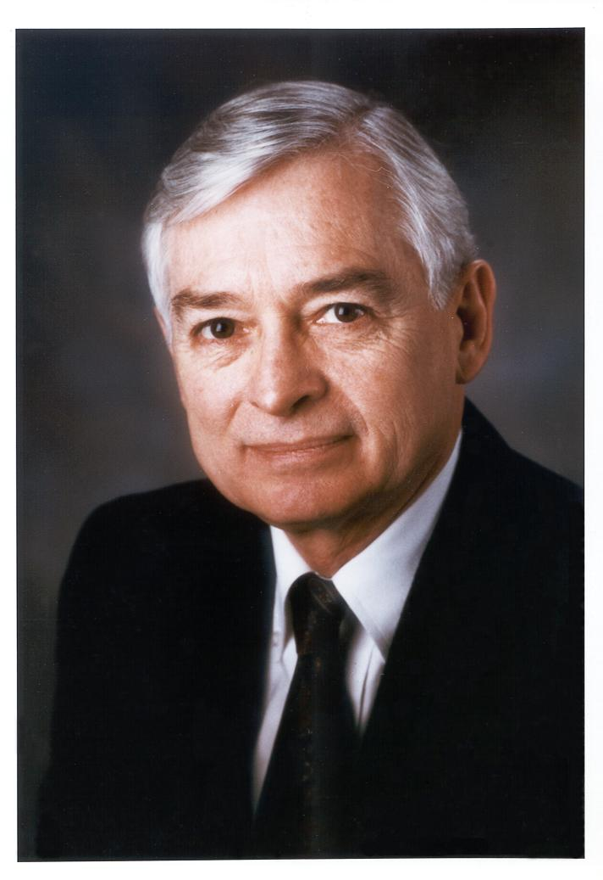
James B. Snow, Jr.

Carrying on in the splendid, over 50-year tradition of the American Otological Society, I am delighted to present to you this evening the 2003 American Otological Society Award of Merit Recipient.

First, I’d like to acknowledge my Award of Merit Committee members – Drs. Chole, Dobie, Konrad, and Lambert. I think you will agree that we have selected an eminently worthy recipient.

And now, according to tradition, the announcement of the honoree. It is not a simple announcement, rather, it is a gradual revelation via photo-documentary, with you, the audience, either vainly trying to figure out the identity of the honoree, or sitting there smugly, having figured it out with the first photo. But remember, no guess counts unless it is written down in advance!

All right – here we go!

Here is our honoree at age 11 months, perhaps contemplating his first steps on life’s journey.

We next see him at age 21 months – a shyly smiling towhead.

Here is our honoree at age 27 months – this photo is where, at least according to his wife, our honoree is recognizable for the adult he is to become.

Our honoree is next seen at age 6, a successful but not particularly jubilant fisherman. Clearly, a career as a fisherman has been ruled out.

We make quite a jump ahead in time here, and see our honoree as a high school student. Note the spiffy necktie – there are portents for the future here!

The dancing couple we see here is our honoree (as a sophomore at the University of Oklahoma) and his bride-to-be (whom he met on a blind date).

After obtaining his BS with distinction, we next see him (in 1952) as a 20-year-old Harvard Medical School student.

I fear this next photo will confirm the guesses of many of you, as see our honoree, at his 1954 wedding celebration in Tulsa, Oklahoma.

Subsequent to completing medical school, AOA and cum laude, our honoree entered the surgical internship program at the Johns Hopkins University. This photo shows our
honoree and his wife standing in front of their apartment strategically located above a gypsy fortune teller and across the street from the Hopkins Emergency room.

We next see the proud parents with their first-born child, a son.

The family grows, with a second son, while Dad is a resident in otolaryngology at the Massachusetts Eye & Ear Infirmary.

Clearly, Dad is a somewhat over eager resident, but then again, when you’re a resident, a “case is a case”!

After serving as a Captain in the 121st Evacuation Hospital in Korea, we next see our honoree in 1964 as the 32 year old Chairman of the Department of Otorhinolaryngology at the University of Oklahoma.

Ok, so now I am sure that virtually all of you recognize that the 2003 American Otological Society Award of Merit Recipient is Dr. James B. Snow, Jr. We all know the serious side of Jim – the man who went on to become the Chairman of the University of Pennsylvania Department of Otorhinolaryngology and Human Communication and to cap his career as the first Director of the National Institute on Deafness and Other Communication disorders. Jim’s cv reveals that he is the epitome of the clinician – investigator --- years of funding from the National Institutes of Health, author/co-author/editor of over 150 papers, 5 books and 40 chapters, Regent of the American College of Surgeons, Member of the Board of Directors of the American Board of Otolaryngology, and officer in almost all of the major societies of our specialty. We expect to see him, as we do here accompanied by his wonderful wife Sallie, as a consulting professor to the People’s Republic of China.

But I’d like to show you a few more photos that reveal a side of Jim that few of us have been privileged to see.

First of all, let’s complete the family, with the third child, Sallie Lee, joining older brothers James B Snow, III and John Andrew. Here we see them at their suburban Philadelphia home, which Jim supplied with firewood for 17 years by his own hard labor.

Here we see Jim again at a DRFA gala with the nifty tie, but it looks like there is a

difference of opinion as to appropriate attire. Here Jim, sans tie, salutes the lobster he is about to demolish.

With grandchildren on the scene, Jim masquerades as Santa, visits the zoo, and indulges in ice cream cones.

In retirement, Jim does anything but relax. Although he does enjoy boating, accompanied by his mascot Sonsie (I leave it to you to decide who’s really in control), Jim remains active in otolaryngology – for example, editing the recently published 16th Edition of Ballenger’s classic text, managing the Tinnitus Research Consortium, and here greeting Queen Biatrix during a recent meeting of the Collegium.

But this photo beats them all – Jim merrily embarking on a PWC! Jim, would you please come forward?

As Jim approaches, I’d like to thank Sallie Snow, Jim’s wonderful wife, and my co-conspirator in this endeavor. Sallie thanks so much – Jim is truly a fortunate man!

Jim, I am delighted to present to you the American Otological Society’s Award of Merit Medal and the certificate which reads “James B. Snow Jr., for his leadership in otology and his continuing leadership in otological research and research education”.

REMARKS OF THE PRESIDENT

HORST R. KONRAD, MD

Falls in the Elderly: A Challenge for the Otologist
Horst R. Konrad, MD

The most rapidly growing segment of our population is the aged population. Age-related falls are among the highest causes of serious injury in this population. Falls-related injuries result in healthcare costs estimated at ninety million a year, and in addition result in limitation in the patient’s activities and quality of life. Falls also affect relatives and other caregivers. A careful risk assessment is helpful in determining the cause of falls and in providing for a systematic treatment course. The assessment includes an evaluation of the patient’s sensory systems including vision, balance, proprioception, hearing, and the patient’s general health status such as cardiovascular and cerebrovascular function, strength and flexibility, reflex speed and osteoporosis. Risk factor evaluation should also include the patient’s home environment and the patient’s medications. The treatment strategy is targeted at the patient’s specific dysfunctions and also the patient’s ability and willingness to work with rehabilitative treatment. The use of assistive devices, change in home lighting, improvement in vision and targeted physical exercise programs with balance retraining have been shown to be very effective in reducing falls and decreasing the patient’s dependence on other individuals. The otologist is in an essential position to work with other members of the healthcare team to evaluate and manage these patients

INTRODUCTION OF THE GUEST OF HONOR

JAMES F. BATTEY, JR., MD PHD

PRESIDENTIAL CITATION

MAUREEN T. HANNLEY, PHD

Scientific Program

Auditory Basic Science Topics

Title: Audiological and Clinical Outcomes in Auditory Neuropathy

Authors
Colm Madden MB, FRCSI
Mark Boston MD
John Greinwald MD
Daniel Choo MD

Primary author is
Colm Madden MB, FRCSI.
Center of Hearing and Deafness Research,
Department of Pediatric Otolaryngology,
Children's Hospital Medical Center,
3333 Burnet Avenue,
Cincinnati, 45229, Ohio, U.S.A.
Phone: 513-636-5897
Fax: 513-636-2886
E-mail: madep6@chmcc.org

Presenting author is
Mark Boston MD
Center of Hearing and Deafness Research,
Department of Pediatric Otolaryngology,
Children's Hospital Medical Center,
3333 Burnet Avenue,
Cincinnati, 45229, Ohio, U.S.A.
Phone: 513-636-4089
Fax: 513-636-2886
E-mail: Mark.Boston@cchmc.org

Audiological and Clinical Outcomes in Auditory Neuropathy

Colm Madden MB, FRCSI, Mark Boston MD
John Greinwald MD, Daniel Choo MD

Objective: To medically and audiologically characterize a population of children diagnosed with auditory neuropathy (AN).

Study Design: A retrospective chart review of patients diagnosed with AN.

Setting: Tertiary care pediatric referral center.

Patients: Thirty-five patients with AN identified from a pediatric otology/audiology clinic.

Outcome Measures: Clinical data, audiometric thresholds.

Results: Thirty-five children were diagnosed with AN at our institution. A genetic factor in AN is suggested by our identification of 3 families (each with 2 affected siblings). Clinical features common amongst our population included a history of hyperbilirubinemia (57%), prematurity (54%), ototoxic drug exposure (48%), neonatal ventilator dependence (37%) and a family history of AN (17%). At least one risk factor was present in 83% of our patients. Full clinical and audiological data was available for all of the 35 children. This included Otoacoustic Emissions (OAEs), Auditory brainstem responses (ABR) with Cochlear Microphonics (CM) and age-appropriate audiometry. Significantly, 16 of these 35 patients showed improvement in behavioral thresholds over time (mean follow-up 31 months, range 0-119), indicating that a subset of children with AN may recover useful hearing levels. A significant improvement was seen in those children with a history of ototoxic medication use at birth (p=0.02). Cochlear implantation provided an effective habilitation in 6 children.

Conclusions: This data shows that management of children with AN requires serial clinical and audiometric evaluations. Prematurity, genetics, hyperbilirubinemia and ototoxic medication appear to be significant factors in the development of AN. A history of exposure to ototoxic medication is associated with spontaneous improvement in hearing thresholds.

Title: Spiral Ligament and Stria Vascularis Changes in Cochlear
Otosclerosis: Effects on Hearing Level
authors: Joni K. Doherty, M.D., Ph.D.
Fred H. Linthicum, Jr., M.D.
primary_authorname: Joni K. Doherty
primary_address: 632 N Topanga Canyon Blvd., Topanga, CA 90290
prim telephone: 323-236-0955
primfaxnumber: 323-226-2703
primemail: jdoherty@usc.edu
presentername: Joni K. Doherty, M.D., Ph.D.
presenter_address: 1200 N. State Street, Rm.#4136, Los Angeles, CA 90033
presenter_telephone: 323-236-0955
presenter_fax: 323-236-0955
presenter_email: jdoherty@usc.edu
presentation method: either, prefer oral

Spiral Ligament and Stria Vascularis Changes in Cochlear
Otosclerosis: Effects on Hearing Level
Joni K. Doherty, M.D., Ph.D., Fred H. Linthicum, Jr., M.D.

Objective: To investigate the pathogenesis of sensorineural hearing loss (SNHL) in cochlear otosclerosis, we (1) define the relationship between spiral ligament (SL) hyalinization, stria vascularis (SV) atrophy, and SNHL; and (2) describe changes within the lateral wall of the cochlea in terms of ion transport channel expression and
fibrocyte survival.
Study Design: Retrospective
Setting: Tertiary referral center
Patients: Seventy-five cochleas from 57 temporal bone donors, ages 49-85 (avg. 71.3), with histologic evidence of CO, including SL hyalinization.

Intervention: Audiography.
Main outcome measures: In basal, middle posterior, middle anterior and apical turns of celloidin-embedded cochlear sections, measurements of SL width and hyalinization were compared with SV and bone conduction hearing thresholds (BCHT). To exclude other causes of SNHL, cochleas were assessed for hair cell, dendrite, and spiral ganglion counts. Expression of the ion transport molecules Na-K-ATPase, connexon26 (Cxn26) and carbonic anhydrase II (CAII) were assessed by immunohistochemical techniques.
Results: SL hyalinization correlated directly with SV atrophy and hearing loss (BCHT) in the middle posterior and apical turns of the cochlea (p<0.05). These relationships did not achieve significance for the basal or middle anterior turns. Decreased CAII, Cxn26, and Na-K-ATPase immunostaining of type I, II, and IV fibrocytes of the SL was observed in CO sections compared with normal cochlea. However, overall immunostaining results were inconsistent.
Conclusions: These data suggest that SL structure and function are essential for SV survival. Additionally, malfunctioning SV may result in altered endocochlear potential and SNHL.
This work was supported by a grant from the NOHR Foundation.

Title: Caspase inhibition prevents apoptosis of trophic factor deprived
auditory neurons
authors: Francois Lallemend,BS 1,2
Syed Ahsan,MD 1
Adrian A Eshraghi,MD 1
Marek Polak,PhD 1
Brigitte Malgrange,PhD 2
Philippe P Lefebvre,MD,PhD 1,2,3
Fred F Telischi,MEE,MD 1
Thomas J Balkany,MD 1
Thomas R Van De Water,PhD 1,2
primary_authorname: Thomas R Van De Water,PhD
primary_address: Univ of Miami Ear Institute, Univ of Miami School of
Medicine, 1600 NW 10th Ave., RMSB3160, Miami, FL 33136
primtelephone: 305-243-4641
primfaxnumber: 305-243-5552
primemail: tvandewater@med.miami.edu
presentername: Thomas R Van De Water, PhD
presenter_address: Univ of Miami Ear Institute, RMSB 3160, 1600 NW 10th Ave,
Miami, FL 33136
presenter_telephone: 305-243-4641
presenter_fax: 305-243-552
presenter_email: tvandewater@med.miami.edu
presentation method: oral
AOS_science_abstract:

Caspase inhibition prevents apoptosis of trophic
factor deprived auditory neurons
Francois Lallemend,BS, Syed Ahsan,MD, Adrian A Eshraghi,MD
Marek Polak,PhD, Brigitte Malgrange,PhD, Philippe P Lefebvre,MD,PhD
Fred F Telischi,MEE,MD, Thomas J Balkany,MD
Thomas R Van De Water,PhD

Hypothesis: Caspases participate in the apoptosis of auditory neurons that occurs following a loss of trophic factor support (i.e. auditory hair cells).
Background: The current trend to implant people with substantial residual hearing requires preservation of enduring sensorineural elements. Because hair cells provide trophic support for auditory neurons, it would be desirable to preserve these sensitive cells in addition to the neurons. Loss of trophic support causes oxidative-stress damage in the auditory neurons and apoptosis. Procaspases are present in healthy hair cells and neurons and when activated are key participants in oxidative-stress initiated apoptosis.
Methods: Dissociated spiral ganglion cell cultures were grown either with or without neurotrophin (hrBDNF). Immunolabeling and Western blots identified caspase activation. Neurotrophin-deprived cultures were treated with pan-and specific caspase inhibitors. Cultures were stained for neurofilaments and the percentage of neuron survival was determined.
Results: These in vitro studies show that several members of the caspase family actively participate in the apoptotic cell death of neurotrophin-deprived auditory neurons. Because more than one caspase participated in the apoptosis of trophic factor deprived auditory neurons the most effective treatment was a pancaspase inhibitor.
Conclusion: Treatment of neurotrophin-deprived auditory neurons with a pancaspase inhibitor prevented the loss of these neurons due to oxidative-stress induced apoptosis. Because caspases have been shown to participate in the apoptotic cell death of both hair cells and neurons a pancaspase therapeutic strategy may have application to cochlear
implantation by reducing the loss of hair cells and any subsequent loss of neurons.

Sound evoked motion of the ossicles in the guinea pig middle ear.
authors: 1) Manoj Kumar MS,FRCS
2)Wei Dong PhD
3)Nigel Cooper PhD
primary_authorname: Manoj Kumar
primary_address: 223 Martin Luther King Dr, Apt 4, Cincinnati 45219, OH
primtelephone: 513-2810958
primemail: manoj.kumar@talk21.com
presentername: Manoj Kumar
presenter_address: 223 Martin Luther King Dr, Apt 4, Cincinnati 45219, OH
presenter_telephone: 513-2810958
presenter_email: manoj.kumar@talk21.com
presentation method: oral

Sound Evoked Motion of the Ossicles in the Guinea Pig Middle Ear

Manoj Kumar MS, FRCS, Wei Dong PhD
Nigel Cooper PhD

Objective: The aim of the experiment was to find out the relative movement of the malleus and incus in response to varying frequencies of sound stimuli.
Method: Experiments were performed in 5 anaesthetized guinea pigs. Surgically, the bulla was exposed. Small holes were made in the bulla to visualize and measure the ossicular movements. A heterodyne laser interferometer was used to measure the sound evoked ossicular motion.
Background: Three orthogonal components are necessary in describing the motion of a point in 3-D space. Direct measurement of these displacement components of the ossicles were not possible, since the interferometer system we used provided information only in one direction of the object under study at a time. The measurements were carried out from a single point on the malleus and incus from a wide range of viewing angles, by rotating the goniometer system attached to the guinea pig head, around the vertical and horizontal axes. This allowed 3D reconstruction of the motion of the ossicles.
Results and Conclusion: 3D reconstruction of the umbo and the end of long process of the incus showed linear motion for low frequency stimuli and more elliptical or circular motion for higher frequency stimuli. The mean lever ratio was calculated from the above recordings increased when the frequency of the sound stimuli exceeded 3.2kHz. The change in the lever ratio appears to reflect a change in the ossicle’s mode of vibration between low and high frequencies.

Discussion Papers 1 – 4

Thomas Balkany, Miami, FL

I would like to address just a comment to Dr. Boston regarding that study. We have implanted only five Russian immigrant children and all of them have had auditory neuropathy. It is very difficult to find out what their blood levels of billirubin are and other things. They have been treated very poorly until the time they arrived in the United States and I just thought it might be interesting for all of us who are going to be seeing Russian immigrant children who are adopted by U.S. parents to see if they end up having a high rate of auditory neuropathy. Thank you.

Saumil Merchant, Boston,MA

I have a question for Dr. Boston. The improvement you found in many of your patients, how much of that can you ascribe to resolution of conductive loss that these infants had from effusions and how much of it is do you think actually an improvement in the functioning of the cochlear nerve?

Dr. Mark Boston, Cincinnati, OH

My recollection is that all of their tympanograms were normal. I can’t recall their exact exams whether they had effusions or not and those resolved. My recollection is that there were no children whose hearing loss on those audiograms either initial or the follow up were confounded by a superimposed conductive component. All of that hearing was a sensorineural component and that the improvement that we saw was either an improvement in the condition or maturation or whatever is going on in auditory neuropathy. This is obviously speculative and remains to be discovered. I don’t feel that there is any conductive component that was improving.

John McElveen, Raleigh-Durham, NC

Also to Dr. Boston. We are seeing the pediatricians allowing higher and higher levels of billirubin before they put the kids under lights. What is the present acceptable high level of billirubin in the newborn?

Dr. Mark Boston, Cincinnati, OH

I’m not sure what the accepted level is. It may vary from institution to institution. I think we are initiating treatment in most cases with a level of 20 or higher at Cincinnati. As I recall we looked specifically at whether the level of billirubin was correlated with either the outcome or the severity of the hearing loss and it was not. Of course it’s a small population and I can’t say much more than we just didn’t find an association with the level or the mode of treatment whether it was just billi-lights or exchanged transfusion or something else. That also did not appear to be correlated with outcomes or with the severity of the hearing loss. So I think at our institution the treatments were instituted for levels of at least 20 and none of our children presented with kirnicteris or other overt neurological problems so they weren’t severely hyperbillirubinemic or at least the treatment was established early enough to prevent that outcome.

Michael Hoffer, San Diego, CA

For Dr. Kumar. That was elegant work that you did. I was wondering if you looked at different sound intensity levels and sound pressure levels to see if that affected motion as well as different frequencies.

Dr.Manoj Kumar, Cincinnati, OH

We used sound pressure level. SPL was the unit we used between 80 to 100. Of course there was difference in the intensity of the recording but that followed the same trend. The equipment that we had we could not measure very low sound. SPL level something like 50 or 60 we couldn’t measure because we didn’t have the technology. For at least 80 decibel SPL which is I think equal to 40 or 50 decibel hearing level, I think that’s what we have done.

Dr. Barry Hirsch, Pittsburgh. PA

For Dr. Boston again. As you saw recovery of the pure tones in these children, did you see recovery of the otoacoustic emissions or the ABR? Did those patterns change as well?

Dr. Mark Boston, Cincinnati. OH
No, actually we did not see any change. In the children that did have ABR follow up and mind you not all of them did but there was not an improvement in the ABR and there was no change in the OAE either. The OAE’s if they were gone never came back and only in one case did we actually observe over time one child loose their OAE’s but there was no other recovery.

Howard Francis, Baltimore, MD

I have a question for Dr. Kumar. To what extent might your frequency specific changes in the lever ratio be explained by middle ear muscles and in any of your experiments, did you section those muscles?

Dr. Manoj Kumar, Cincinnati, OH

The VQ in deep anesthesia and we were checking reflexes in between so I don’t think the muscles were working at that time. Also we carried out experiments after sacrificing the animal. There wasn’t any. Of course there was difference again in the intensity but the pattern was the same.

Dr. Manohar Bance, Halifax, Nova Scotia

I have a question for Dr. Kumar. I understand your calculating lever ratio by dividing the displacement of the malleus by displacement of the incus, it goes up with higher frequencies. To what extent could that be explained by losses of the incudo-malleolar joint which would result in a loss in the movement of the incus but does not represent a true pressure gain. It gives you an artificial increase in lever ratio but doesn’t represent a pressure gain it just represents a decrease in the amount of that movement?

Dr. Manoj Kumar, Cincinnati, OH

That is a good question, thank you. In guinea pigs there isn’t much motion between the incus and malleus. It’s sort of almost fixed or continuous. So in humans you’re right there should be an inference of the sliding action of the incudo malleolar joint. Thank you.

Dr Saumil Merchant, Boston, MA

This is for Dr. Dougherty. I really enjoyed your very beautiful oto-temporal bone pathology work. I just have a comment the term cochlear otosclerosis. There is a lot of literature on what cochlear otosclerosis means and it means different things to different people. Do you use the term to imply otosclerosis that affects the inner ear causing sensorineural hearing loss without any stapes fixation so there’s no air bone gap and you have an unexplained sensorineural hearing loss except for the otosclerosis? I’m assuming that many of these patients you showed had stapes fixation so you may want to just take that into account when you use the term cochlear otosclerosis.

Dr. Joni K. Doherty, Los Angeles, CA

Yes many of our specimens did have stapes footplate fixation and we defined cochlear otosclerosis as lesions involving the cochlea.

Dr. Saumil Merchant, Boston, MA

Dr. Schuknecht made a big deal about not believing in cochlear otosclerosis and published many papers titled things like A Continuing Fantasy, etc. etc. But that having been said Dr. Fred Linthicum showed very clearly that there are bones that have nothing else except massive otosclerosis without stapes fixation and we at the Mass U. have also bones that show that same kind of pathology. The point is that these bones are extremely rare. If you look at the incidence of otosclerosis causing pure sensorineural hearing loss without stapes fixation, without an air bone gap, those are a very small number.

Dr. Joni Doherty. Los Angeles, CA

It’s been estimated about 3% of all bones that exhibit otosclerosis. Thank you.

Dr. Anthony DeLaCruz, Los Angeles, CA

I have a question for Dr. Van De Water. How close are we to delivering capsace inhibitors to cochlear implant systems and will that increase a high possibility of implants?

Dr. Thomas Van De Water, Miami, FL

Thank you for that question Tony. Actually probably were not going to deliver caspace inhibitors for this particular situation because we have things that are actually much more effective and we are now defining the cell depth pathways that are upstream of the caspaces, especially looking at the Macon H junk cell pathway. This actually appears to be much more effective. I presented something a week ago at the Cochlear Implant Conference down in Washington on the Macon H junk cell pathway. We are aiming to deliver drugs during implantation to lessen the effect of trauma on both the half cells and the auditory neurons.

Dr. Robert Goldenberg, Dayton, OH
I’d like to congratulate Dr. Kumar also on an elegant study. In the slide you showed Dr. Kumar of that break in the lever action there’s a break at 1500 hertz and I wondered if there was any significance in that finding?

Dr. Kumar:
I’m sorry could you repeat that again?

Dr. Goldenberg:
Yes, in your calculation of the lever action where you are doing all the different frequencies, low, mid and high frequency ranges, there’s a break a very distinct break at 1500 hertz as opposed to a higher or lower frequency.

Dr. Kumar:
We used octaves like 100, 200, 400, and 800 and why there’s a break, we don’t know. But when we recorded motion function we noticed that sort of break. We don’t know why there is a break. Thank you.

Panel Discussion

Panel- Noise-Induced Hearing Loss: Current Status and New Directions

Abstract

This panel discussion will focus on various aspects of noise-induced hearing loss (NIHL). In the first presentation, Dr. Dobie will describe the epidemiology of NIHL including dose relationships, intersubject variability, and relationships to age related hearing loss. He will then discuss audiologic features of NIHL for individual diagnosis. Dr. Lonsbury-Martin will then review her use of distortion product otoacoustic emissions (DPOAEs) to track NIHL development, including early detection, and recovery in both animal and human studies. Additionally, she will present her work with DPOAEs to describe permanent NIHL and correlations with cochlear changes. Dr. Kopke will review new information regarding molecular mechanisms involving NIHL. He will relate the mechanistic information to a variety of noise exposures and implications for preventative and treatment strategies. Drs. Campbell and Rybak will then review the most promising otoprotective agents for NIHL prevention and rescue. Results in animal models will be presented with a discussion of the putative mechanisms of otoprotection for the various agents. The presentations will be followed by a question and answer period.

Panel:

Moderator:
Leonard P. Rybak, MD, PhD
Professor of Otolaryngology
Southern Illinois University School of Medicine
Springfield, IL

Speakers:

Kathleen Campbell, PhD
Professor and Director of Audiology
Southern Illinois University School of Medicine
Springfield, IL

Robert Dobie, MD
Director, Division of Extramural Research
NIDCD
Bethesda, MD

Richard Kopke MC, USA
Director, Department of Defense Spatial Orientation Center
Department of Otolaryngology
Naval Medical Center San Diego
San Diego, CA

Brenda Lonsbury-Martin, PhD
Professor and Vice Chair of Research
Department of Otolaryngology
University of Colorado Health Sciences Center
Denver, CO

Dr.Leonard Ryback, Springfield. IL

Thank you Dr. Konrad. Members and guests I’d like to peak your interests today with a topic that has undergone some exciting new discoveries in the last decade or so, noise induced hearing loss. In the past all we could do was describe the pathology and try to put on ear protectors but now with military and other industrial sounds that are being projected on our society we are experiencing an epidemic of noise induced hearing loss. With our panel this morning we hope to show you some exciting new possibilities for pharmacological treatment for prevention and perhaps rescue of damage of noise induced hearing loss. We have assembled an outstanding panel of speakers to talk to you about various aspects of noise induced hearing loss. Their presentations will be relatively short and will be open for discussion at the end. It should provoke a lot of discussion. I would like to introduce our first speaker; Dr. Robert Dobie who will talk to us about the epidemiology of noise induced hearing loss.

Dr. Robert Dobie, Washington, D.C.
Epidemiology of Noise Induced Hearing Loss

Dr. Brenda Lonsbury-Martin, Denver, CO
Physiological Aspects of Noise Induced Hearing Loss Using a Tool of Otoacoustic Emissions

Dr. Richard Kopke, San Diego, CA
Population at Risk for Hearing Loss at the Present Time

Dr. Kathleen Campbell, Springfield, IL
Glutathione

PANEL DISCUSSION:

Dr. Leonard Rybak,

I’d like to start the questions by asking Dr. Brenda Lonsbury-Martin about the potential for gene therapy for noise induced hearing loss. Have there been any animal experiments and do you think it may be practical to consider such therapy in humans?

Dr. Brenda Lonsberry-Martin:

Well that’s quite a provocative question. Of course with the mouse model a lot of the gene therapy work is being initiated. The mouse makes a nice model of noise induced hearing loss, so projecting up the road here I would believe that would be a possibility when the right substances and knowledge about noise induced hearing loss and the genetic basis of it is available. So that would be a natural progression and one would then predict that if that becomes a reality then when gene therapy becomes a reality for humans, that would be a natural extension of that work but I know of no work right now going on of that sort, particularly to noise induced hearing loss.

Dr. Leonard Rybak

I’d like to ask Dr. Campbell about the doses of the protective agents and whether she’s considered the possibility of using some sort of a cocktail to reduce the doses of the individual components?

Dr. Kathleen Campbell

Little early in the day for cocktails Len but certainly there is some things we need to consider. Particularly if we start running into any tolerance or safety issues with any of the antioxidants that we are working with, alcarnak, demothiane, laceofloic acid is affective certainly we could go to lower doses of each in combination considering the efficacy of them and that is something we will be looking at. Right now it looks like we’ll be able to give these as oral well-tolerated doses that have been well established for other purposes in the literature and can be administered safely on a chronic basis. Keep in mind that some of these agents and again I’ll talk about demothiane because as you know we’ve been working with that for a longer period of time in my particular lab so I’m even more familiar with it, but when we start getting into the human dosing on that we can get down pretty close to what you’d use for nutritional supplementation in the IV line of a patient after a gastric bypass surgery. That’s really how it should work out so we know we should be able to deliver that quite safely. But in the future certainly we may be using a combination of agents and the other thing is that we may have certain patient populations that cannot use one agent or another so we certainly want more than one option like we always want more than one treatment option for any disorder.

Dr. Leonard Rybak

I’d like to ask Dr. Dobie if there are certain subpopulations of subjects who are more susceptible to noise injury than others.

Dr. Dobie

The short answer is yes but we don’t know who they are. As Brenda pointed out and as the epidemiological data show, there are a lot of variations to susceptibility. There are tough ears and tender ears. Some people have wondered about things like blue eyes versus brown eyes, smoking versus nonsmoking. The bottom line is we really don’t know how to predict at the beginning of a person’s noise exposure that is going to get more hearing loss, which has tough ears, who has tender ears. Otoacoustic emission studies like Brenda talked about may prove to be worthwhile, that hasn’t been shown yet but it has potential value but as of now the most practical thing to do is to treat individuals who demonstrate early shifts in a hearing conservation program as if they were more susceptible.

Dr. Leonard Rybak,

I’d like to ask Dr. Kopke, have you been seeing a lot of military personnel with noise induced hearing loss and what have you been able to do with them up to this point?

Dr. Kopke:

Well I see as an otologist a lot of patients in the military with noise induced hearing loss in different contexts. I see folks that are retiring after 20 years of service that may require hearing aid amplification on a regular basis. We also see individuals that loose hearing suddenly after noise exposure, some of those to a severe level. We treated some of those people with oral steroids and had a couple of patients with severe to profound sensorineural hearing loss after noise that were treated with oral steroids, didn’t recover and had more direct delivery of steroids to the round window membrane and did recover. However what we are trying to do now and what is in place is a clinical trial for prevention and later for treatment of acute acoustic trauma with acetylcholine and so we are going to look at that on a more systematic basis but for now you know just sort of some antidotal information. I will say that hearing conversation measures are always emphasized and re-emphasized. There is research going on in developing better hearing protection devices, making weapon systems noisier but a lot of that research is down the road or hasn’t panned out. Unfortunately data from Doug Olin suggests that over the last two or three years rather than continuing to decline VA disability payments for hearing loss in the military are actually going up precipitously and I expect after this last conflict there will be a bit of increase in that as well so we still have work to do.

Dr. Leonard Rybak,

I would like to ask you another question about the particular susceptibility of astronauts to noise induced hearing loss in space.

Dr. Kopke,

I think that’s an interesting point. As you know we have consulted with NASA a few times because of some concerns about noise induced hearing loss with long-term space flight and I think that data is still under evaluation. I would say that maybe it’s not as much of a problem as initially thought but the situation in space is like being on an aircraft carrier. There’s really no completely quiet place to go and even though OSHA has determined that safe noise levels are below 85 dB, that’s considering a rest period of 16 hours with every 8 hour period of noise exposure. So if you don’t get that rest period, you may get damage from lower levels of noise than you suspect.

Dr. Lonsbury-Martin,

May I add to that? I was just going to say that we really don’t know how the air operates long term in micro-gravity too; you know sounds that are not dangerous on earth may become dangerous in that kind of environment.

Dr. Leonard Rybak,

Exactly. I’d like to thank the panelist for their participation and thank the audience for paying attention to our presentations.

Autoimmune Inner Disease

Title: Kinectics of Round Window Permeability

Douglas E. Mattox, MD
Don R. Christian, MD
Jake A. Gilbert, BA
Girlandia Goepfert, MD
Henry F. Edelhauser, PhD
Presenter:
Douglas E. Mattox, MD
Department of Otolaryngology - Head and Neck Surgery
Emory Clinic, Room A 2328
1365 Clifton Road, NE
Atlanta, GA 30322
Phone 404-778-2525
FAX 404-778-4295
This material has not been presented or is under consideration by another national or international meeting. Douglas E Mattox.

Kinectics of Round Window Permeability
Douglas E. Mattox, MD, Don R. Christian, MD
Jake A. Gilbert, BA, Girlandia Goepfert, MD
Henry F. Edelhauser, PhD
Hypothesis: This study used a novel in vitro perfusion chamber to establish quantitative data on the permeability of the round window membrane (RWM) to 3H-dexamethasone, 3H-water and diclofenac (NSAID).
Background: Intratympanic drug delivery is becoming an increasingly important tool in the management of inner ear diseases including autoimmune hearing loss, sudden hearing loss and Meniere's disease. Although the transport of numerous molecules and particles across the RWM has been described, an actual permeability constant (Ktrans) for various drugs and molecules has not been defined. We have established an in vitro model to test the permeability of the RWM to various molecules.
Methods: The RWM of adult guinea pigs was mounted on a perfusion device, which clamped the RWM between two chambers. The upper chamber (middle ear side) allowed for a depot of drug. The lower chamber (inner ear side) was continuously perfused with balanced salt solution. A fraction collector collected the outflow every hour for 24 hours. The amount compound that had diffused through the RWM was measured in a liquid scintillation counter. The average permeability constant, Ktrans, (cm/sec) over the 24 hours period was calculated.
Results: The Ktrans for 3H-dexamethasone was 1.5+/- 0.4 X 10-7 and 3.1 +/- 0.8 X 10-5 for 3H-water (p<0.001). The RWM was impermeable to diclofenac for 12 hours.
Conclusions: This study shows the feasibility of an in vitro method to measure RWM permeability. Both 3H-dexamethasone and 3H-water were permeable to the RWM, with the later having a significantly higher permeability constant. The RWM was impermeable to diclofenac.
Supported by the American Otologic Society Research Fund and Alcon Laboratories, Ft. Worth, Texas.

Title: Intratympanic Gentamicin Therapy for Meniere's Disease: A
Meta-Analysis
authors: Stanley H. Chia, M.D.
John P. Anderson, Ph.D.
Jeffrey P. Harris, M.D., Ph.D.
primary_authorname: Stanley H. Chia
primary_address: 3412 Herman Ave, Unit A, San Diego, CA 92104
primtelephone: 619-284-3493
primfaxnumber: 619-543-5521
primemail: stanchia@yahoo.com
presentername: Stanley H. Chia
presenter_address: 3412 Herman Ave, Unit A, San Diego, CA 92104
presenter_telephone: 619-284-3493
presenter_fax: 619-543-5521
presenter_email: stanchia@yahoo.com
presentation method: either, prefer oral
aos_reviews:

Intratympanic Gentamicin Therapy for Meniere's Disease:
A Meta-Analysis
Stanley H. Chia, M.D., John P. Anderson, Ph.D.
Jeffrey P. Harris, M.D., Ph.D.

Objective: This study compares the effectiveness of different techniques of intratympanic gentamicin administration for Meniere's Disease.
Data Sources: Medline search for English language literature, 1978-2002, was performed
using key words: intratympanic, gentamicin, therapy, Meniere's, disease.
Study selection: Inclusion criteria to select articles for meta-analysis were: clear description of gentamicin delivery technique; clearly reported vertigo control results; report of hearing loss post-treatment. Eight studies (n=247) describing the multiple daily dosing technique (TID delivery for >=4 days); seven studies (n=262) describing the weekly/biweekly dosing technique (weekly/biweekly injections for fixed number of doses or termination with vertigo relief); four studies (n=103) of the low dose technique (1-2 injections with retreatment for recurrent vertigo); four studies (n=156) of continuous microcatheter delivery; and five studies (n=241) of the titration technique (daily or weekly doses until onset of vestibular symptoms) were entered into the model.
Data extraction: Vertigo control results were stratified into complete, substantial, or
poor control. Hearing results were separated by profound, partial, or no hearing loss. Patients were further divided into those receiving <120 mg of gentamicin (low dose group, n=278), and >=120 mg (high dose, n=323).
Data synthesis: Rates of vertigo control and hearing loss between delivery techniques
and dosage groups were analyzed by chi-square.
Conclusions: Maintaining gentamicin dosage under 120 mg can decrease hearing loss
(p<0.05) without sacrificing vertigo control. Titration method of delivery provides the greatest complete vertigo control (P<0.01). Low dose therapy has the least associated hearing loss (p<0.05), but also less vertigo control (p<0.05) when compared to titration and multiple daily dosing methods

. TITLE OF ABSTRACT:
Randomized Trial of Methotrexate for Autoimmune Inner Ear Disease

AUTHORS:
Jeffrey P. Harris, M.D., Ph.D.
M. Jennifer Derebery, M.D.
Mark A. Espeland, Ph.D.
Bruce J. Gantz, M.D.
A. Julianna Gulya, M.D.
Michael Weisman, M.D.
For the AIED Study Group

PRIMARY AUTHOR:
Jeffrey P. Harris, M.D., Ph.D.
University of California, San Diego
Division of Otolaryngology-Head & Neck Surgery
200 W. Arbor Dr. #8895
San Diego, CA 92103-8895
619.543.7896.
fax 619.543.5521
jpharris@ucsd.edu

PRESENTER AT COSM:
Jeffrey P. Harris, M.D., Ph.D.
University of California, San Diego
Division of Otolaryngology-Head & Neck Surgery
200 W. Arbor Dr. #8895
San Diego, CA 92103-8895
619.543.7896.
fax 619.543.5521
jpharris@ucsd.edu

Randomized Trial of Methotrexate for Autoimmune Inner Ear Disease

Jeffrey P. Harris, M.D., Ph.D., M. Jennifer Derebery, M.D., Mark A. Espeland, Ph.D.
Bruce J. Gantz, M.D., A. Julianna Gulya, M.D., Michael Weisman, M.D.
for the AIED Study Group

Context: A number of therapies have been proposed for the long-term management of steroid-responsive rapidly progressive bilateral sensorineural hearing loss (RPBSHL), i.e. autoimmune inner ear disease (AIED). However, none of these therapies had been rigorously evaluated.

Objective: To assess the efficacy of methotrexate (MTX) in maintaining hearing gains achieved with corticosteroid (prednisone) therapy in AIED.

Design, Setting, Participants, Intervention: A double-blind, randomized, placebo-controlled trial conducted from January 1998 to September 2002 at 10 otolaryngology out patient clinics in the United States. Of 116 participants with RPBSHL, 67 “responded” to prednisone and accepted randomization to either oral MTX (up to 15 – 20 mg weekly; 33 patients) or placebo (34 patients), in combination with prednisone taper. Follow-up examinations, including audiometric evaluation, were carried out at 4, 8, 12, 24, 36, 48, and 52 weeks, or until hearing loss was documented, whichever came first.

Main Outcome Measure: Time after the date of randomization to loss of hearing gain achieved with prednisone.

Results: In the intention-to-treat analysis, MTX was no more effective than placebo (fitted relative hazard 1.31 ± 0.34, p = 0.29) in preventing the loss of hearing gained with prednisone.

Conclusions: MTX does not appear to be effective at the dosage used in this study in maintaining the hearing gain achieved with prednisone therapy in AIED.

Acknowledgement: NIH/NIDCD and the American Academy of Otolaryngology/Head and Neck Surgery.

Title of Abstract: Hearing Loss as an Early Manifestation and Indicator of Exacerbation in Wegener’s Granulomatosis

Authors: Mark S. Driver, MD, Sivasanker Bakthavachalam, Jeffrey H. Spiegel, MD, Clarke Cox, PhD, Kenneth M. Grundfast, MD, Peter A. Merkel, MD, MPH
Department of Otolaryngology-Head and Neck Surgery and Section of Rheumatology, Department of Medicine, Boston University School of Medicine

Primary Author and Presenter: Mark S. Driver, MD
Dept. Of Otolaryngology – Head and Neck Surgery
Boston University School of Medicine
D616, 88 E. Newton St.
Boston, MA 02118
617-638-7934
Email: marksdriver@hotmail.com
Fax: 305-946-8071
**Note** This is a corrected version of the abstract:

Hearing Loss as an Early Manifestation and Indicator
of Exacerbation in Wegener’s Granulomatosis

Mark S. Driver, MD, Sivasanker Bakthavachalam,
Jeffrey H. Spiegel, MD, Clarke Cox, PhD,
Kenneth M. Grundfast, MD, Peter A. Merkel, MD, MPH

Objective: Describe the frequency, type, and clinical course of hearing loss in patients with Wegener’s Granulomatosis (WG).
Study Design, Setting, and Patients: Retrospective cohort study of all patients with WG seen in one year at an academic medical center.
Main Outcome Measures: Hearing loss documented by pure-tone audiogram.
Results: 35 patients included: 19 men, 16 women; mean age 55 years (range 22-87); 32 were ANCA-positive, mean disease duration of 47 months. (2-196). 15 patients (42.8%) had documented hearing loss: Accounting for mixed losses, 12 (34.2%) had sensorineural (SNHL) and 10 had conductive loss (CHL). 3 of 9 cases of CHL improved with treatment of WG (cyclophosphamide) 1 worsened and 1 remained stable. Of 12 patients with SNHL; 1 improved, 1 worsened, and 3 remained stable (on cyclophosphamide). 7 patients had hearing loss requiring amplification. 5 of 35 (14%) patients had established hearing loss months-years prior to diagnosis of WG. Hearing loss occurred both upon initial presentation and with disease relapse.
Conclusions: Both SNHL and CHL are common in WG, may result in significant morbidity, and may precede the diagnosis of WG by years. CHL is more likely to improve with treatment of WG than SNHL. The significance of both types of hearing loss in patients with WG may be used as a manifestation helpful in diagnosis and as an indicator of severity before other manifestations are manifest. These data suggest that it may be appropriate to perform screening audiograms in all patients with newly diagnosed or relapsed WG.

Discussion Papers 5 – 8

Dr. Michael Ruckenstein, Philadelphia, PA

Two questions. One for Dr. Chia and one for Doctor Harris. Dr. Chia that was a wonderful paper. I’m looking forward to seeing it in the literature. My eyes are failing me however and I wondered if you could elucidate for us, which were the studies that incorporated titration technique, which specific studies? And for Doctor Harris, Jeff we all have patients on Methotrexate, I have to put you on the spot a little bit. Are you recommending that if patients are being sustained on Methotrexate with a seemingly descent result, should we discontinue Methotrexate on them because of the potential complications and secondly do you have any suggestions to us for other Prednisone sparing drugs that we can incorporate now instead of Methotrexate?

Dr. Stanley Chia, San Diego, CA

I’m not sure if I can bring the slides back up from my talk but the studies from the titration method were by Outfest in 1988, Beckenschmitt in 1978, Beck in 1986, by Lloyd Minor in 1999, Hirsh and Kemor in 1997 and Lida Carey in 1989.

Dr. Jeffrey Harris, San Diego, CA

Michael you can’t put me on the spot. The answer to your question is if you have a patient who is currently doing well on Methotrexate, I would not recommend that you stop. However, if their hearing is falling, I wouldn’t continue. As far as new recommendations I really can’t give you what the best treatment would be, based upon the fact that what we thought was useful is not. I think that other drugs that are currently available could be proved to be just as ineffective. I would tell you to use high dose steroid and try to get them off of it as slowly and judiciously as possible and perhaps even intratympanic steroids but again we have no proof that that’s any more effective.

Dr. Alan Rubin, Toledo, OH

I enjoyed Dr. Driver’s talk. I just want to ask him if he could speculate as to the pathogenesis of the middle ear or the conductive component of hearing loss and why over time it generally gets better?

Dr. Mark Driver, Boston, MA

A number of these patients who have the conductive loss tend to have middle ear effusions, many of which will resolve with steroids and Methotrexate However there is a subset of the group who developed granulomas within the middle ear. They tend to be less responsive, including to surgery, they tend to not do as well. So we believe that may be the reason.

Dr. Mitchell Schwaber, Nashville, TN

I wanted to ask a question of Jeff again. I may have missed it but how many of the patients had a concomitant other autoimmune illness, rheumatoid arthritis or lupus. Were those patients responsive to treatment?

Dr. Jeffery Harris, San Diego, CA

I’ll have to get back to you on that. There were a small percentage of patients that were admitted with simultaneous rheumatoid arthritis or other immunologic diseases. RA seemed to be the one that had the greatest likelihood. We had a change in protocol shortly after we began the study and we did open it up to patients with systemic rheumatologic disease. According to the results as far as I recall there was no difference between their outcome and the other patients.

Dr. Barry Hirsch, Pittsburgh, PA

Jeff if these patients do come off their steroids after six or eight months and say taper off, did you see their
hearing loss start to come back again? In other words were they stabilized or did they continue to progress

Dr. Jeffery Harris, San Diego, CA

We have six writing groups that are actively studying the various outcomes of the cohort of patients. That will be the discussion of a second or third paper that’s coming out. It hasn’t been analyzed yet so I can’t give you the answer.

Dr. Vincente Honrubia, Los Angeles, CA

This is for Doctor Maddox. I want to congratulate Dr. Maddox for his work. He has a record of always asking the most embarrassing question, and this has been one of those cases. In view of your results of the kinetics of transfer through the round window membrane, what would be your thoughts about interpreting the results of the papers on the effect of perfusion of the middle ear with Gentamicin? Would you give us a practical justification of your work?

Dr. Douglas Mattox, Atlanta, GA

Well this is just one little piece of the puzzle. If you look at transtympanic therapy, there are issues of input and issues of output. The input is the permeability of the membrane and the output is what happens to the drug in the middle ear, the metabolism, the clearance, the binding etc. Our goal was to dissect the system and once we have a better handle on at least one part of the equation then we can expand in vivo studies and look at the entire equation.

Dr. Jeffrey Harris, San Diego, CA

Doug I also wanted to congratulate you on that nice study. In your model is this a static system that has lost its blood supply? If so, the transport of solutes or drugs depends on active transport. How do you think that might affect the results and do you know whether there’s an active transport?

Dr. Douglas Mattox, Atlanta, GA

Presumably there is an active transport because very large molecules can go across the membrane. We carry these out for in some cases 48 hours and the permeability remains constant. Often, around the 36th hour or so, the permeability would abruptly go through the roof and we assume the membrane finally ruptured. At least within that time frame it seemed to be stable in a totally isolated situation. It is oxygenated I forgot to mention but obviously there’s no blood flow.

Dr. Joel Goebel, St Louis, MO

For Dr. Chia on the low dose studies. Did you study the patients who had repeated injections until the physician felt that they had reached a clinical response? Some of the low dose studies may have stopped at one or two injections. Some of the patients didn’t get further injections on the low dose study because that’s a technique that’s been very useful. I’m discouraged to see that the control isn’t as aren’t completely
controlled. You don’t inject to a point where you create symptoms but you inject repeatedly to a point that their vertigo is controlled.

Dr. Stanley Chia, San Diego, CA

All of those patients were included in the group including the ones who had re-treatment. In order to be included in the low dose protocol, the definition was if they received one or two treatments then that’s all they needed with no recurrent vertigo, then that was considered a success of that group. If they required repeated treatments, if they had no further vertigo after say four treatments, they were included in the same data set. That included everything from one treatment until five or six treatments for repeated systems.

Dr.Joel Goebel, St. Louis, MO

And they were all followed out to the two-year limit?

Dr. Stanley Chia, San Diego, CA
Correct. Some of our studies did not include the two-year AOHNS criteria in order to try to increase the number
of patients included in our study. I believe that most of the patients in the low dose protocol had the two-year follow up.

Surgical Treatment of Conductive Hearing Loss

Title: A Comparison of Ossiculoplasty with Stapes to Malleus and Stapes to
Eardrum Prostheses
authors: 1 Manohar Bance MB, MSc, FRCSC
2 David P. Morris MBBS, FRCS(ORL-HNS)
3 Rene G. van Wijhe BSc, M.Eng
4 Rachael Smith MD
primary_authorname: Manohar Bance
primary_address: Room 3184, Dickson Blding, VGH Site, QEII HSC, 1278 Tower
Rd, Halifax, NS, Canada, B3H 2Y9
primtelephone: 902 473 5975
primfaxnumber: 902 473 4345
primemail: m.bance@dal.ca
presentername: Manohar Bance
presenter_address: Room 3184, Dickson Blding, VGH Site, QEII HSC, 1278 Tower
Rd, Halifax, NS, Canada, B3H 2Y9
presenter_telephone: 902 473 5975
presenter_fax: 902 473 4345
presenter_email: m.bance@dal.ca
presentation method: oral

A Comparison of Ossiculoplasty with Stapes to

Malleus and Stapes to Eardrum Prostheses

Manohar Bance MB, MSc, FRCSC, David P. Morris MBBS, FRCS(ORL-HNS)
Rene G. van Wijhe BSc, M.Eng, Rachael Smith MD

Hypothesis: In the ear with a missing incus, reconstruction from the stapes head to the
malleus will result in different stapes responses compared to reconstruction to the eardrum.
Background
In the ear with a missing incus, two commonly used reconstruction methods
either a prosthesis from the stapes head to the malleus (Malleus Stapes
Assembly (MSA)), or a prosthesis from the stapes head to the eardrum
(Partial Ossicular Replacement Prosthesis - PORP). The differences in
function are not clear. Our objective was to compare these reconstructions
in a cadavaric human middle ear model.
Methods
Eight fresh human cadaveric temporal bones were harvested within 48 hours
after death. The stapes footplate vibrations were measured using a Laser
Doppler Vibrometer, and compared for the two types of reconstruction. The
tympanic membrane was stimulated with a sound input of 80 – 95 dB SPL over
a frequency range of 0.2 to 8kHz. Measurements were made for several
lengths of each prosthesis to allow for the confounding effects of tension.
Results
Our results show substantial differences in the performance of the MSA and
PORP prostheses, in some narrow frequency ranges. On average, the results
were within 10dB of each other.
The differences are complex and frequency dependant. In general, MSA
resulted in slightly better high frequency responses.
Conclusions
The stapes responses for MSA and PORP prostheses show differing resonances
at narrow frequency ranges within each bone. Overall, the results are not
separated by more than 10 dB.

TITLE OF ABSTRACT: Hearing Outcome of Laser Stapedotomy Minus Prosthesis (STAMP) Versus Conventional Laser Stapedotomy
AUTHORS: List all authors in proper sequence (numbering 1, 2, 3, etc., if applicable) using FIRST NAMES, MIDDLE INITIALS, AND LAST NAMES AND EXACT DEGREES. (No changes accepted after 10/15/02)
Herbert Silverstein, MD
Karen K. Hoffmann, MD
Lance E. Jackson, MD
Jack H. Thompson, Jr., PhD, PA-C
Joshua P. Sleeper, BA
NAME, ADDRESS, TELEPHONE, FAX NUMBER, E-MAIL OF PRIMARY AUTHOR:
Herbert Silverstein, MD
1961 Floyd St., Suite A, Sarasota, FL 34239
941-366-9222 phone
941-366-3238 fax
hsilverste@aol.com
NAME, ADDRESS, TELEPHONE, FAX NUMBER, E-MAIL OF PRESENTER AT COSM:
Karen K. Hoffmann, MD
1961 Floyd St., Suite A, Sarasota, FL 34239
941-366-9222 phone
941-366-3238 fax
karenhmd@netscape.net
The material in this abstract has not been submitted for publication, published nor presented previously at another national or international meeting and is not under consideration for presentation at another national or international meeting. I understand that the penalty for duplicate presentation/publication will prohibit me and my co-authors from presenting at a COSM Society Meeting for a period of three years. I accept sole responsibility for statements in the abstract.
Submitting Author's Signature (required): Karen Hoffmann

Hearing Outcome of Laser Stapedotomy Minus Prosthesis
(STAMP) Versus Conventional Laser Stapedotomy

Herbert Silverstein, MD ,Karen K. Hoffmann, MD
Lance E. Jackson, MD, Jack H. Thompson, Jr., PhD, PA-C
Joshua P. Sleeper, BA

Objective: To compare short and long-term hearing outcomes for patients undergoing primary laser stapedotomy minus prosthesis (STAMP) versus conventional laser stapedotomy.

Study design: Retrospective case review of 156 patients over a 9-year period between 1993-2002.

Setting: Otology/neurotology tertiary referral center.

Patients: Those with clinical otosclerosis without previous otologic surgery.

Interventions: Patients with otosclerosis confined to the fissula ante fenestram underwent STAMP. Patients with more extensive otosclerosis or anatomical contraindications to STAMP underwent standard laser stapedotomy.

Main Outcome Measures: Pure-tone audiometry was performed before surgery, post-operatively, and on follow-up examination.

Results: Of the 174 ears in 156 patients, 110 (63.2%) underwent laser stapedotomy, and 46 (36.8%) underwent STAMP. Of the 40 patients in the STAMP group with an average of 701 days (SD 439) follow-up, the air-bone gap closed from a mean of 21dB (SD 10 dB) to 5 dB (SD 6 dB). In comparison, 83 stapedotomy patients with an average of 717 days (SD 772) follow-up, the air-bone gap closed from a mean of 27 dB (SD 11 dB) to 7 dB (SD 8 dB). There was a statistically significant improvement in high-frequency hearing in the 2000-8000 Hz range in the STAMP patients, with an average difference of 22 dB compared to the stapedotomy group. Five patients required revision surgery after STAMP, but were successfully repaired with conventional stapedotomy.

Conclusion: Laser STAMP, when used for isolated anterior footplate otosclerosis, provides improved high frequency hearing compared to conventional laser stapedotomy, and has a low incidence of refixation necessitating revision surgery.

Title: Partial Promontory Technique In Stapedotomy Cases With Narrow Niche
Authors: 1. Michelle M. Inserra, MD
2. Patricia J. Yoon, MD
3. Theodore P. Mason, MD
4. Joseph B. Roberson, MD
Name, address, telephone, fax, e-mail of primary author:
Michelle M. Inserra, MD
Stanford University Medical Center
Div. of Otolaryngology/Head & Neck Surgery
Rm. 135, Edwards Building
Stanford, CA 94305-5328
650-326-5878 (H)
650-725-8502 (fax)
m_inserra@hotmail.com
Name, address, telephone, fax, e-mail of presenter:
same as above.

Partial Promontory Technique in Stapedotomy Cases with Narrow Niche

Michelle M. Inserra, MD, Patricia J. Yoon, MD
Theodore P. Mason, MD, Joseph B. Roberson, MD

Objective: Examine clinical and audiometric outcomes of laser partial promontory approach to stapedotomy cases with a narrow oval window niche.

Study design: Retrospective chart review.

Setting: Tertiary referral center.

Patients: Fifty-nine patients who underwent a partial promontory technique with stapedotomy between 1994 and 2000. Seventy-two patients who underwent primary stapedotomy without promontory technique served as a control group.

Methods: Preoperative and postoperative audiometric results were obtained for 59 patients undergoing laser stapedotomy with a narrow oval window niche. The partial promontory takedown was performed with a KTP laser. Results were compared with 72 primary laser stapedotomy cases without promontory technique within the same time period and analyzed using a paired student’s t-test.

Results: Ninety percent of the partial promontory cases were successful (ABG < 10 dB). The mean postoperative ABG was 5.1 dB which was comparable to the non-promontory cases (p=0.7). The mean change in postoperative bone conduction was also comparable (p=0.98). There were no cases of sensorineural hearing loss. An overhanging facial nerve was present in 32% of the narrow niche cases and a dehiscent facial nerve encountered in 17% of these cases.

Conclusions: Partial laser takedown of the promontory as an adjunct to laser stapedotomy cases with a narrow oval window niche is a safe, effective technique with comparable results to primary laser stapedotomy.

Title: A New Approach for Malleus/Incus Fixation; No Prosthesis Necessary
authors:

Michael D. Seidman,MD., FACS
Seilesh Babu, MD
primary_authorname: Michael D. Seidman, MD
primary_address: Henry Ford Health System, Dept of Oto-HNS 6777 W. Maple Rd,
W. Bloomfield, MI 48323
primtelephone: 248-661-7211
primfaxnumber: 248-661-6456
primemail: mseidma1@hfhs.org
presentername: Michael D. Seidman, MD., FACS
presenter_address: Same
presenter_telephone: Same
presenter_fax: Same
presenter_email: Same
presentation method: oral

A New Approach for Malleus/Incus Fixation; No Prosthesis Necessary

Michael D. Seidman, MD., FACS, Seilesh Babu, MD

Objective: To describe a novel approach to manage malleus/incus fixation.
Study Design: Retrospective review of 363 patients with conductive hearing loss
operated on since 1992.
Setting: Academic tertiary referral center
Patients: 363 patients with conductive hearing loss, an intact tympanic membrane and
without history for chronic infection underwent middle ear exploration. 341 had otosclerosis and underwent laser stapedotomy; the remaining 22 patients had laser release of their malleus/incus fixation.
Intervention: 22 patients were diagnosed with malleus fixation prior to surgery. Conductive hearing loss was identified using audiometry and tuning forks. The diagnosis was confirmed using micropneumotoscopy and noting immobility of the malleus. A transcanal approach was used and the malleus/incus fixation was released using a laser. A 1.5 to 2.0 mm space was created where the ossicular fusion existed, thereby reducing the likelihood of re-fusion.
Main outcome measure: Audiometric studies pre and post intervention were compared. 1-10 years of follow up are provided.
Results: Pre-operative air-bone gaps ranged from 25 dB to 60dB and averaged 45
dB. Post-operative air-bone gaps ranged from 0-25 and averaged 10 dB. No patients have experienced re-fusion. There were two complications: One perforation requiring a tympanoplasty and one patient sustained a 20 dB high frequency sensorineural loss
Conclusion: The idea that malleus/incus fixation should be repaired by removing the
incus and using a POP is outdated. The approach presented provides an opportunity to leave the anatomy relatively undisturbed. The results are excellent and this approach should be considered in most cases with mallues/incus fixation. A video will be presented.

Trans Facial Recess Ossicular Chain Reconstruction: Surgical Technique and Early Results

Nikolas H. Blevins, MD

750 Washington Street
NEMC #850
Boston, MA 02111
(617) 636-5494
(617) 636-1479 (fax)
nblevins@lifespan.org
Submitted for oral presentation
AOS Spring Meeting, 2003

Trans Facial Recess Ossicular Chain Reconstruction:

Surgical Technique and Early Results

Nikolas H. Blevins, MD

Objectives: To present the technique of trans facial recess ossicular chain reconstruction (TFROCR) for use in selected patients with cholesteatoma.

Study Design: Retrospective review of all candidates for TFROCR between 8/98 and
10/02.

Setting: Tertiary referral center
Patients: At their first procedure, 19 patients (8 children, 11 adults) with cholesteatoma and ossicular discontinuity were identified as candidates for staged TFROCR. Seven patients had undergone previous tympanomastoid surgery.

Intervention:
The first stage included canal wall up mastoidectomy with resection of disease, wide opening of the facial recess, cartilage graft tympanoplasty, and placement of silastic in the middle ear. Approximately 6 months later, patients underwent a second stage post-auricular procedure. Endoscopes were used to inspect the middle ear through the facial recess. When possible, TFROCR was then performed, without elevating a tympanomeatal flap.

Main Outcome Measures:
Variations in anatomy, disease characteristics, and hearing results were studied.

Results:
Of the 19 candidates, 15 successfully underwent TFROCR, and 4 required traditional second stage procedures with canal incisions. There were no surgical complications. Early hearing results are promising, with an average air-bone gap of less than 20 dB. There have been no early failures from recurrent disease or prosthesis displacement.

Conclusions:
In carefully selected patients, TFROCR may be safe and effective for disease control and hearing restoration. It may provide for optimal prosthesis placement and almost immediate hearing improvement, avoiding the need for canal incisions, middle ear packing, and dry ear precautions. One must consider the potential risk of missing residual disease secondary to limited exposure.

Discussion Papers 9 – 13
Dr. John House, Los Angeles, CA

Comment and question for Dr. Herb Silverstein. Herb, how does this lengthen the time of your surgery? It seems to me it’s a lot of extra work. Secondly, why do the patients have a higher incidence of a progressive high frequency sensorineural hearing loss? Is that because the groups that are standard stapedectomies have more involvement of otosclerosis than the patients that do have the STAMP procedure? And last, you concluded that you had few complications, however you had two dead ears in 55 cases and that’s much higher than we see with standard stapedectomy.

Dr. Herbert Silverstein, Sarasota, FL

As far as the dead ears I have nothing much to say about that. As far as the time of the surgery, it does take a little longer especially when you are first starting to do this. If you don’t have a good exposure it’s not worth it to take the time to do it. If you do take more of the scutum down, you can do the procedure. As far as the high frequency loss, I thought that there were two reasons. One, the size of the piston being so small and also the trauma of the surgery of doing a stapedotomy versus preserving most of the footplate. I think preserving most of the footplate leaves the patient in a more normal situation and there appears to be less deterioration in the hearing. As far as the dead ears, that may be because of our learning experience in the early cases of doing this procedure.

Dr. John McElveen, Raleigh Durham, NC

Question for Dr. Seidman. I wanted to have some clarification on what you do after you’ve done your atticotomy. It wasn’t clear to me, do you cover that with some cartilage or do you just put the silastic in there or do you just cover it with fascia? I’m thinking about short-term results and long-term the concern about the possibility of cholesteatoma developing.

Dr. Michael Seidman, Detroit, MI

In all cases I have used a really large flap and I’ve not had any re-retraction but I certainly think that could be a potential problem. One patient obviously had a perforation and so we used some fascia as I recalled but you can use Alloderm. It is certainly not unreasonable to put in a piece of cartilage to prevent that from happening, that’s not a bad idea.

Dr. John May, Winston Salem, NC

I have a question for Dr. Bance. I wondered if he had used his model to compare ossiculoplasty with and without the head of the malleus?

Dr. Manohar Bance, Halifax, NS

I’m sorry I missed, with and without what sir?

Dr. John May, Winston-Salem, NC

Did you compare results or have you considered studying the malleus handle, the presence of the malleus handle with the head of the malleus removed?

Dr. Manohar Bance, Halifax, NS

We haven’t done that ourselves but the group at Stanford has done some work removing the head of the malleus with the micromechanics afterwards. In fact there’s actually a slight improvement in the higher frequency responses when you remove the head of the malleus.

Dr. John May, Winston-Salem, NC

That really has been my experience and I was just curious if based on your studies there’s any reason not to remove the head of the malleus.

Dr. Manohar Bance, Halifax, NS

I don’t think there is a reason not to remove the head of the malleus, in fact, you probably gain some high frequency benefit.

Dr. Douglas Mattox, Atlanta, GA

I think Dr. Seidman’s point about careful observation of malleus mobility preoperatively is very important. I’ve seen patients who have had this problem that’s been missed elsewhere. But I really have a question for the gathering here. How many here have used a technique very similar or identical to what was described this morning? A show of hands. I’m surprised it’s not more than that. I thought this was how you took care of the problem of malleus head fixation.

Dr. Herbert Silverstein, Sarasota, FL

I would like to make one comment. If you do make a mistake and miss a malleus fixation after you put in the prosthesis, and you’re ready to close, this is a perfect time to use the laser to release the fixation.

Dr. John Shea, Memphis, TN

I want to congratulate Dr. Seidman for clarifying a big problem that’s been out there about 25 years. It’s interesting that he quoted the paper by Fred Guilford. Three of us reported that same problem in the same month in 1967.The one paper he quoted was a paper from our clinic and I’m a third author in it and that really was my work. We’ve been studying this problem for 25 years. I’m not used to palpating the incus and malleus before I do a stapedectomy. Does he have any clue from the audiology whether these patients are going to have epitympanic fixation or does he palpate the incus and malleus in all patients on whom he’s going to do stapedectomy? I’m interested in if you do, what’s the scope you use to do that?

Michael Seidman, Detroit, MI

I focus as high as my microscope goes and frankly I’m embarrassed to say I don’t know how high that is. I have three settings at one office and two at another. I put it at the highest setting and I look. It’s difficult with the residents that I teach. They are all saying “I’m not sure if I see it moving or not”.

I had a long conversation at ARO with Saumil Merchant, I don’t know if he’s in the audience but Saumil could probably answer your question better about the Otologic characteristics. I didn’t see any difference; I just saw a 20-30 sometimes 40 decibel air bone gap across the board. Is Saumil Merchant here by any chance e? Maybe you can comment about the audiologic configuration because your article at ARO was wonderful in that regard.

Saumil Merchant, Boston, MA

The question is how does the audiogram look when you have malleus head fixation? We have been investigating this problem in a variety of ways. We have done some experimental work using human temporal good but many times low dose requires a patient coming back month after month if their symptoms

bones where we will measure the middle ear sound transmission and then fix the malleus head with different simulator pathologies so that we can get an idea of what the conductive loss would be. We have also done measurements using the laser Doppler vibrometry technique in patients who have had malleus head fixations. This early work suggests that if you fix the malleus head with what appears to be fibrous tissue type fixation, you get about a 5-10 dB, probably a 5 dB conductive loss. If you have a bony bar fixation which is a single bar of bone going from the malleus head to the epitympanic wall like what Mike you showed, you get about a 20 dB air bone gap, 20-25 dB below frequency cap. If you then have a much larger degree of malleus head fixation like new bone completely filling the attic like you see in some patients with chronic otitis media, you can get a 30-35 dB air bone gap. We are trying to fix the anterior malleolar ligament. We have not had much success seeing a significant air bone gap by isolated fixation of the anterior malleolar ligament. This is work that has just occurred in the last few months. We will probably publish it or present it later in the year or next year. Thank you.

Dr. Jay Farrior, Tampa, FL

Just an observation on patients with malleus fixation as opposed to the standard upward sloping conductive hearing loss seen with otosclerosis. Quite often it’s a parallel loss, as Dr. Merchant just talked about. A 20 decibel conductive loss that is relatively flat in a person with no history of Otologic problems might be a tip off to malleus fixation.
Dr. Robert Goldenberg, Dayton, OH

I also enjoyed Dr. Sideman’s presentation. Six percent is a rather high percentage of malleus fixations in your series and I wondered if you could comment on what your pathophysiology was, what was the pathology in those 22 cases?

Dr. Michael Seidman, Detroit. MI

About a third of them were congenital, a lot of children and younger adults. I would say that a third was tympanosclerosis or actually just firm new bone I don’t really know what the other third were.

Sunday, May 4, 2003

Superior Canal Dehiscence

Title: Investigations of the Effect of Superior Semicircular Canal
Dehiscence on Hearing Mechanisms
authors: 1. John J. Rosowski PhD
2. Jocelyn E. Songer MS
3. Heidi H. Nakajima MD, PhD
4. Kelly M. Brinsko BS
5. Saumil N. Merchant MD
primary_authorname: John J. Rosowski PhD
primary_address: Eaton-Peabody Lab, Massachusetts Eye and Ear Infirmary,
243 Charles Street, Boston, MA 02114
primtelephone: 617 573 4237
primfaxnumber: 617 720 4408
primemail: jjr@epl.meei.harvard.edu
presentername: John J. Rosowski PhD
presenter_address: Eaton-Peabody Lab, Massachusetts Eye and Ear Infirmary,
243 Charles Street, Boston, MA 02114
presenter_telephone: 617 573 4237
presenter_fax: 617 720 4408
presentation method: oral
AOS_science_abstract:

Investigations of the Effect of Superior Semicircular Canal
Dehiscence on Hearing Mechanisms
John J. Rosowski PhD, Jocelyn E. Songer MS
Heidi H. Nakajima MD, PhD, Kelly M. Brinsko BS
Saumil N. Merchant MD
Hypothesis: Superior Semicircular Canal Dehiscence (SSCD) affects hearing function by introducing a third window into the inner ear which: (a) lowers cochlear input impedance, (b) shunts sound away from the cochlea, and (c) improves bone conduction thresholds by increasing the difference in impedance between the vestibule and round-window membrane.
Background: Besides affecting the vestibular system, SSCD has also been linked to a “conductive” hearing loss characterized by a decrease in the sensitivity to air-conducted sound and hyper-sensitivity to bone-conducted sound.
Methods: Laser-Doppler vibrometer measurements of sound-induced umbo velocity were performed in patients with CT confirmed SSCD. The effect of SSCD on bone and air-conducted sounds were studied in chinchillas. Anatomically-based theoretical analyses of sound flow through the cochlea and semi-circular canals were performed.
Results: (1) The umbo-velocity in five SSCD patients with no other complications ranged from normal through hyper-mobile. Such hypermobility is consistent with a decrease in cochlear impedance produced by a shunt path that allows sound to flow away from the cochlea. (2) Measurements in eight chinchilla demonstrated that creating an SSCD can lead to increases in the cochlear potentials produced by bone-conduction stimuli. This
increase mimics the hyper-sensitivity to bone-conducted sound observed in patients with SSCD. (3) An anatomically based model predicts changes in auditory sensitivity that have features in common with the clinical and experimental measurements of hearing function in SSCD.
Conclusions: The results are consistent with the hypothesis that SSCD introduces a third window into the inner ear.
IRB Approval number for Human studies: 00-09-041
IRB Approval number for Animal studies: 91-11-027
Work supported by NIDCD R01 DC 04798 and R01 DC 00194

Title: Superior Semicircular Canal Dehiscence presenting as "Conductive" Hearing Loss without Vertigo
authors: 1. Anthony A. Mikulec, MD
2. Mitchell J. Ramsey MD
3. Michael J. McKenna MD
4. Joseph B. Nadol, Jr., MD
5. Steven D. Rauch, MD
6. John J. Rosowski PhD
7. Hugh D. Curtin, MD
8. Saumil N. Merchant MD
primary_authorname: Saumil N. Merchant, MD
primary_address: Department of Otolaryngology, Massachusetts Eye and Ear
Infirmary, 243 Charles Street, Boston, MA 02114-3096
primtelephone: (617) 573-3503
primfaxnumber: (617) 573-3939
primemail: snm@epl.meei.harvard.edu
presentername: Anthony A. Mikulec, MD
presenter_address: Department of Otolaryngology, Massachusetts Eye and Ear
Infirmary, 243 Charles Street, Boston, MA 02114-3096
presenter_telephone: (617) 573-3651
presenter_fax: (617) 573-3939
presenter_email: amikulec@stanfordalumni.org
presentation method: oral
AOS_clinical_abstract:

Superior Semicircular Canal Dehiscence presenting as
"Conductive" Hearing Loss without Vertigo
Anthony A. Mikulec, MD, Mitchell J. Ramsey MD
Michael J. McKenna MD, Joseph B. Nadol, Jr., MD
Steven D. Rauch, MD, John J. Rosowski PhD
Hugh D. Curtin, MD, Saumil N. Merchant MD

OBJECTIVE: To describe superior semicircular canal dehiscence (SSCD) presenting as otherwise unexplained "conductive" hearing loss without vestibular symptoms.
STUDY DESIGN: Retrospective.
SETTING: Tertiary referral center.
PATIENTS: Seven patients (9 ears); ages 29-61 yr; M:F = 3:4.
DIAGNOSTIC TESTS AND RESULTS: All 9 ears had SSCD on high resolution temporal bone CT scan. There were no middle ear findings to explain the air-bone gap in these 9 ears (including negative middle ear exploration in 6 ears; of these 6, stapedectomy had been performed in 3 ears but the air-bone gap was unchanged post-operatively). Air-bone gaps were largest at 250, 500 and 1000 Hz: the averaged gap for these 3 frequencies for the 9 ears ranged from 32-52 dB. Bone conduction thresholds below 2000 Hz were negative
(-5 to -15 dB) at one or more frequencies in all 9 ears. Laser vibrometry showed umbo motion to be above mean normal in all 8 ears tested. Vestibular evoked myogenic potentials (VEMP) were present in all 3 tested ears. The audiometric and laser vibrometry data are consistent with SSCD producing an apparent conductive loss by shunting air-conducted sound away from the cochlea and improving thresholds for bone-conducted sounds by increasing the difference in impedance between the oval- and round- windows.
CONCLUSIONS: SSCD can present with a "conductive" hearing loss that mimics
otosclerosis, and may explain some cases of persistent conductive hearing loss after uneventful stapedectomy. Audiometric testing with attention to absolute bone conduction thresholds, laser vibrometry of the umbo, VEMP testing and CT scanning can help to identify patients with SSCD presenting with apparent conductive hearing loss without vertigo.

Title: LONG TERM RESULTS OF MASTOID OBLITERATION WITH BONE CEMENTS
authors: Jennifer L. Maw, MD
primary_authorname: Jennifer Maw
primary_address: 2030 Forest Ave Suite 210, San Jose, 95128
primtelephone: 408-885-9500
primfaxnumber: 408-280-5594
primemail: jlm@earmd.net
presentername: Jennifer Maw
presenter_address: 2030 Forest Ave Suite 210, San Jose, CA 95128
presenter_telephone: 408-885-9500
presenter_fax: 408-280-5594
presentation method: oral
AOS_clinical_abstract:

Long Term Results of Mastoid Obliteration
With Bone Cements

Jennifer L. Maw, MD

Objective: To report the long-term outcome of mastoid obliteration using bone cements.
Study design: Case series
Setting: Private otologic practice
Patients: Thirteen patients aged 17 to 51 with a history of a mastoid cavity and chronic mastoid problems who wanted to undergo a mastoid obliteration procedure
Intervention: Revision tympanomastoidectomy and mastoid obliteration or canal wall reconstruction with a commercially available bone cement.
Main outcome measures: Complete healing of ear, dry ear and time to required revision surgery.
Results. Eight patients underwent mastoid obliteration with dahllite bone cement (Norian CRS cement (Synthes)) and three patients with hydroxyapatite cement (Bone Source (Leibinger)). Palva flaps were performed in 2 of each procedures. Two patients underwent canal wall reconstruction, one with each cement. Initial results looked promising with near or complete healing and dry ears at 6 months in 9 patients. Eleven of the 13 procedures eventually failed over 2 years with occurrence of granulation tissue formation and/or cement exposure in the ear canal and otorrhea. One patient fistulized
through the post-auricular incision. Revision surgery was required in 10 patients (mean time from obliteration surgery was 20 months) and all underwent successful removal of the bone cement and mastoid obliteration with bone pate. There were no cases of sensorineural hearing loss. One patient had extensive middle ear fibrosis and obliteration of the round window with a maximum conductive hearing loss. Granulation tissue showing chronic inflammation and foreign body response was present between the temporal bone and cement except for the bony labyrinth.
Conclusions: While early results look promising, mastoid obliteration with the currently available dahllite and hydroxyapatite bone cements have an unacceptable long-term complication rate. Canal wall reconstruction with use of a Palva flap requires further consideration and study.

Discussion Papers 14 – 16
Dr Robert Dobie, Washington, DC

I have a question for Dr. Merchant or the gentleman who presented for his group, I’m sorry I forgot your name. It looked as though only one of those eight cases had a Carhart notch and is the absence of that notch a clue? The second question is shouldn’t all of these patients have an intact stapedius reflex? In the one case where you didn’t have it, was it just because you couldn’t present adequate stimulus and if that’s the case what about bone conduction stimulus for the acoustic reflex and with those clues maybe you wouldn’t have to buy a VEMP machine.

Dr. Saumil Merchant, Boston, MA

Thank you for that, those are very good points. You are right. Only one case had what appeared to be a Carhart’s notch, the others did not. That is a clue. In regards to acoustic reflex, yes, Lloyd Minor had told us last year the presence of a reflex would be a good clue that this entity might be present. We found that to be the case except in that one case with a large conductive loss of 50 or 60 dB. I think it might be that we are not presenting the sound at an adequate threshold to elicit the reflex. Your idea of doing the reflex by bone conduction is a great idea and we haven’t thought of that but we will certainly look into that.

Dr. Herbert Silverstein, Sarasota, FL

I have two questions to Dr. Rosowski. I’d like to ask why we don’t see a conductive hearing loss in patients with large cholesteatomas and fistulas of the horizontal canal that we see so commonly. Secondly I’d like him to describe this VEMP test since I’m not familiar with it.

Dr. Saumil Merchant, Boston, MA
Herb if you don’t mind I’ll answer for John. The cholesteatoma patients are very interesting if they have a fistula. They have a conductive loss from the middle ear disease; the air bone gap is compounded by the middle ear pathology. Some of our patients with lateral canal fistula from a cholesteatoma do have hypersensitivity of the bone conduction. If you do masked bone conduction and you compare the bone on the side of the fistula to the bone conduction threshold on the contra-lateral side, you’ll often see it to be 5 dB, 10 dB better on the side of the fistula. This is in line of this model that a fistula can give you hypersensitivity to bone conduction. Of course the problem in cholesteatoma is with the fistula you can get inner ear pathology, labyrinthitis etc which could depress the bone and you don’t see that. I was talking with Allen Miko about his observations with some patients with fenestration or otosclerosis where it was his impression that there might be better than normal bone hypersensitivity to bone after fenestration surgery. There are a lot of things which we didn’t know about this entity that we are discovering now and I think it is fascinating. I don’t have all of the answers but we hope to in the future. The VEMP is a test where you induce a response from the sternocleidomastoid muscle by giving sound into the ear canal and it’s a measure of sacular function. Lloyd is probably the best person to give you details of the test as well as any other vestibular people who are experts.

Dr. John Shea, Memphis, TN

I’d like to make a few historical comments. This business of this unexplained conductive hearing loss is not new. When I first went to California to work with Howard House and study with him in 1954, he was aware of these patients with what was called then by Howard and now John and I and others an unexplained inner ear conductive hearing loss. For anybody who’s done a series of stapedectomies, all of us have opened up ears and found with ordinary air bone gaps you find no otosclerosis. I have been looking at not doing stapedectomy on anybody that didn’t have otosclerosis. This was a problem for people that were doing fenestration. They would sometimes go ahead with this great big operation fenestration and not get a hearing improvement. Well Rosen to his everlasting credit, was a real thinker and he said
”Gosh before I do a fenestration I want to look in the middle ear and verify the presence of otosclerosis”. He inadvertently mobilized the stapes of one of the people in that first series. This started the whole stapes era because he reported this case and those of us who read and studied this paper began to think about it. This is an old problem and I must say I’m delighted to learn about this because I’ve been aware of these people with big air bone gaps, you open them up and they don’t have otosclerosis. There’s another test that makes eminent good sense I’d like everybody to become aware of, these people don’t have a round window reflex. You can push on the stapes in these ears and they don’t have a round window reflex because the wave motion is being dissipated in this superior semicircular canal defect. Now, people with large cochlear aqueducts are part of this same group. They have internal conductive hearing losses. They don’t have a round window reflex and you don’t get improvements when you do operations on them and in people with large modulus. Thank you once again for these very interesting presentations.

Dr. Jim Saunders, Oklahoma City, OK
I had more of a comment than a question for Jennifer’s paper. I feel obliged to comment since she acknowledged me. I’ve presented my results with 30 of those patients that did either partial or complete reconstructions and now I got a little over two years follow up. My failures, I’ve revised four of them, three for infection and one for recurrent cholesteatoma. I have, based on Jennifer’s observations and mine in those three revisions altered the techniques slightly and now what I do Jennifer is place a little thin layer of bone pate over the reconstructed cement and I do think that adds one additional barrier. The problem in this type of surgery as opposed to cranioplasty’s is we have, even in the best situation a very thin tissue layer, soft tissue layer covering the material. My conclusion for those failures is that I do think the little micro-fractures that sometimes occur in the cement as it’s setting up play a role. I’m very careful about if there’s any kind of fracturing of the material then I’ll take it out immediately. Do you have any comments on that?

Dr.Jennifer Maw, San Jose, CA

Thank you for your comment Jim. I do agree that if there is any micro-fracturing at all I’d take it out and start over or just abandon the obliteration procedure. I was comfortable with the reconstruction. I’ve been using the material for cranioplasty for a long time and I felt that there was no fracture at the time that I was putting it in. I know your technique you’ve also been using a different flap and I think we just have to work it out and it sounds like you’re on the right track and we have to continue to work out the best option.

Dr. Robert Jarsdorpher, Charlottesville, VA
Just a brief comment. The concept of a third window is not new. Juergon Torndoff 25 or 30 years ago wrote about that in reference to the small bony apertures from the middle ear to the inner ear through which the nerves and blood vessels would run. He did some cat experiments where he would block off the round window and to confirm that there was indeed the presence of a third window, so just a short comment.

Dr. John Rosowski, Boston, MA

Thank you Dr. Jarsdorpher you’ll also see that Von Bekesey talked about the third window in 1945/1946 in his book. It does have a history and we are aware of it, thank you.

Vestibular Panel
Sunday, May 4, 2002

Moderator: P. Ashley Wackym, Milwaukee, WI

Case Presentation

A 41 year old woman presents with a 2 ½ year history of episodic vertigo. Her attacks include a spinning sensation that would last days often associated with headaches and visual changes. In between she would have periods where she was just motion sensitive. Her hearing wasn’t fluctuating. She had right-sided tinnitus that did not change during the attacks. She had no oral fullness but was missing work and limiting her activities. During her workup she had a 15 dB asymmetric hearing loss with high frequencies in her right ear. She also had a right-sided vestibular paresis on the order of 31% and an MRI was ordered. As seen on the MRI, on the right is this large loop of aica in the internal auditory canal. So, panelists what would you do with this patient?

Dr. John Carey question to Dr. Bruce Gantz, Iowa City, IW

How often do you see that loop when you do an MR on somebody?

Dr. Bruce Gantz, Iowa City, IW

I think I would certainly start out with medical therapy. Neil’s question certainly gets right to the root of the issue. I’m not sure that we have an exact answer for how often we see that as an incidental finding on MRI, but it’s not unheard of. In terms of the outcome measures of vascular loop decompression, they are somewhat mixed in terms of their long-term efficacy and its one of those steps that once you have taken it there’s no turning back and there are lots of different things you can do with medications.

Dr. John Carey, Baltimore, MD

Do we have physiologic evidence whether there’s conduction slowing in the 8th nerve?

Dr. P. Ashley Wackym

That would be an appropriate next step and so an ABR is ordered and that study was normal. There was no evidence of cross compression of at least the cochlear nerve. So, in taking the earlier mentioned suggestion, she was initially treated with medical management. Klonapen did not resolve her symptom complex and so she was placed on Depacote and she’s had no further attacks, no disequilibrium and she’s working again full time. So with this being a likely a vestibular migraine, how do you manage vestibular migraine?

Reply from Panel

The first thing we do is start with behavioral changes making sure that there’s a good nights sleep, make sure they are not missing meals and then go through a whole series of eliminations of foods and beverages that are known to be triggers. We can identify anything of that type since there are no diagnostic tests then it starts to really push the issue of migraine being associated with it. From that point then we work into the use of typically prophylactic medications. Everybody’s got their favorites. We typically start with the tricyclic antidepressants using Nortriyptyline or Amytriptyline in ten milligram dosages and increasing over time, letting the patient titrate basically until they get an affect or they get symptom side effects that are too much.

Speaker (not identified):

Well I guess the one thing we also add is a migraine diet, avoidance of foods that contain tannin such as red wines and cheese and other medications John?

Dr. John Carey

I would second the lifestyle changes and the dietary changes. I think patients often brush that off and I’ve been surprised at the number of patients who come back when I really push the diet that will find it was peanut butter or nuts or yogurt or something that’s on the list that seems totally innocuous but is actually very important. The other important point and what I see probably most often is that both patients and doctors are too impatient. This does not improve over night. The diet takes 4-6 weeks to show an affect. Any prophylactic medication when its titrated up as Neil said slowly which takes 4-6 weeks to reach a maintenance dose and then another 4-6 weeks to really know if its effective. I tell patients you are looking at three months before you’re really going to feel significantly better. I use the calcium channel blockers a lot, especially in young people. They have the fewest side effects. Tricyclics work well if patients are sleeping poorly and that’s a good option. A lot of the neurologists that we work with like the anti-seizure medications like Depacote. There’s a whole variety of things and it just takes a lot of patience.

Speaker (not identified):

What about kids versus adults?
Speaker (not identified):

I’ve had several kids, particularly adolescents and girls at menarche seem really to be at risk for this and I’ve seen several cases with BPV and vestibular migraine develop and it’s hard to know what’s the horse and what’s the cart. Both need to be treated after consulting with the pediatric neurologist. I think either the calcium channel blockers or anti-seizure drugs are good choices for them. They do very well and many of them are very diet sensitive.

Speaker (not identified):

One of the things that we see with the children especially the young girls that have not started their menses yet, is that many times they’ll come in with their complaints where they will not have started headaches so what you are basing this on is the old benign paroxysmal vertigo of childhood type of presentation together with the fact that you turn around and take the history from the mother and you find that she has classic migraines and you work with it from there. But we also have had very good success with chocolate; it seems to be a particular one in the younger.

Speaker (not identified):

In the literature the medications shown on the screen here have been used typically with adults. I’ll start with tricyclics unless there’s a contraindication for those and as outlined march up on the dose. Typically I’ll use calcium channel blockers second and beta blockers third with adults. With children I’ll always start with Propranonol usually one half milligram per kilogram dose for them and like the other panelists, it’s been quite effective. What about migraine, how common is migraine, what about vertigo and migraine, how common is that? Say, relative to some other vestibular disorders that you see?

Speaker (not identified):

I think depending on how you define migraine and each classification system that you use, use a more liberal definition up to 30% of people can be described as having experienced migraine at some point in their life.

Speaker (not identified):

Clearly we have a biased group that come into our clinic but at the present time as we go back retrospectively look at it we deal with migraine associated dizziness in the range of 26 to 30% of all the patients that we see so it is very frequent. It’s a biased group because most of the other things that are fun to see that we could take care of very quickly are taken care out on the front lines so it’s a biased referral issue but it is very common. Interestingly enough migraine has been in the neurology literature since about the mid 1860’s. Migraine has been in the literature since 1174 in terms of relationship between migraine and dizziness.

Speaker (not identified):

From the neurology literature, women of childbearing age 25% roughly and all migraine patients about 10% of the population. Vertigo can occur in up to 35% of migraine population and as you can see here migraine and vertigo is seen in about 3.5% of the U.S. population, if you go back and look at those earlier prevalence data and combine those with incidence of migraine in the population. What about migraine versus a disease like Meniere’s? Do you believe this slide that migraine in vertigo is more common than Meniere’s disease?

Speaker (not identified):

Yes. The differentiation becomes very difficult because they both can produce the same symptoms and early stages with the same test results.

Speaker (not identified):

Yes and that’s a good point and actually when I was studying for the Neurotology specialty examination which I took last Monday, I ran across a paper that Newton Coker and Herman Jenkins published in 1987 where they reported a patient with vestibular migraine who also had a unilateral hearing loss that presented much in the same way that Meniere’s disease can so it’s really a disease entity that I’ve come to recognize as much more common.

Dr. P. Ashley Wackym

Case Presentation

This is a case of a 38-year old man who presented with an acute onset of right oral fullness and hearing loss in July of 2000 and then experienced his first episode of rotatory vertigo in September of 2000. His workup before he came to see us included a gadolinium enhanced cranial MRI that was normal. His vertigo was initially controlled on a low salt diet and Dyazide and his vestibular studies when he first had his vertigo in September of 2000 showed a 56% reduction caloric responses in the right ear. Then about a year later when he was basically asymptomatic, that asymmetry had substantially reduced. It was only a 27% reduction of caloric responses in the right ear. That’s his audiogram initially in March of 2000 when he is having symptoms and then after he had improved on a low salt diet and Dyazide, his audiogram on the right there with the resolution of his pure tone thresholds to normal range. Then a little bit later on in January of 2002, he experienced an increase in his right aural fullness and decline in hearing in his right ear. He complained of some transient imbalance but no vertigo. His diuretic was changed to Acetazolamide or Diamox and he was treated with a pulse and tapered course of Prednisone, initially at 60 milligrams a day and then tapering from there. He had some improvement, actually had considerable improvement in his symptoms on the oral Prednisone but developed a number of side effects from oral Prednisone and did stop taking the Prednisone. So he received an injection of intra-tympanic Dexamethasone into his right ear, 12 milligrams per cc at the first injection in February 2002 and then over the succeeding two weeks noted some improvement in his hearing and also resolution of the other symptoms and then finally that’s his audiogram in January 2002 before the oral Dexamethasone and subsequent intra-tympanic Dexamethasone and then June of 2002 now with resolution of his symptoms and improvement of his hearing. The one question I would ask for the panel is, did the Dexamethasone do anything or is that the natural history of his Meniere’s disease?

Speaker (not identified):

You’re going to have to wait and see; you don’t have enough information. I think you could just be looking at the natural history of the disease.

Speaker (not identified):

What about the role of allergy? Do you think they have a mold allergy during the seasons of March and January when they are inside although probably less so in Baltimore than they are in Wisconsin? What about that?

Speaker (not identified):

Yes I think that there’s some very compelling evidence that allergy can have an important role in Meniere’s disease. Phil do you routinely send your patients for allergy testing or get an allergist involved or what are your criteria for determining when you’ll get an allergist involved in their treatment?

Dr. P Ashley Wackym

I usually don’t but when I saw the pattern I couldn’t resist asking for an allergy evaluation. I have the same problem with intra-tympanic Dexamethasone also oral steroids with these patients, when do you stop using that and how long is the benefit going to be provided? Those are frustrating management questions and I know a year ago today when I broke my clavicle and then had a brachial plexus neuritis and was on high dose steroids for seven weeks and it’s not a benign treatment.

Speaker (not identified):

I think the response could be due to the steroids and one thing I think of when I see these cases is maybe what we call Meniere’s is not one disease and that there are a group of diseases that have a final common pathway. The inner ear can only express symptoms in a limited number of ways, tinnitus, aural fullness, vertigo and hearing loss. When patients have all of those together we call it Meniere’s disease but when patients come in with cough and shortness of breath and chest pain we don’t jump to the conclusion that they have pneumonia. They may have cancer, they may have sarcoidosis, there’s a whole differential that comes up and we don’t yet have the diagnostic sophistication to be able to separate these different disorders. It’s possible that this is a case of an immune mediated Meniere’s syndrome and that it did respond to the Dexamethasone.

Dr. P. Ashley Wackym

Our time is short, why don’t we open up for discussion in the brief time that we have remaining.

Dr. Richard Ruggles, Cleveland, OH

I was interested to hear just at the end that you talked or mentioned allergy. We’ve had a great deal of success in managing our people with skin end-point titration and provocative neutralization food testing and have found a great deal of information that has helped these people. I think its well worth doing.

Dr. Michael Hoff, San Diego, CA

Actually for Neil Shepard, that was a great presentation and I don’t think I’ve ever seen rehab explained so elegantly in such a compressed period of time. Two questions for you, first of all what is your role of anxiety treatment in these patients that are undergoing rehab at your center? Second, in light of a couple published abstracts at ARO the last couple of years using rehab with medicine for migraines, what do you feel the role of vestibular rehab is for migraine patients?

Dr. Neil Shepard, Newton Square, PA

First of all for both groups if the symptom complexes is appropriate where with what we are dealing with are head motion provoked or visual motion provoked symptoms, especially in the anxiety group, you have a lot of visual motion provoked symptoms, rehab does provide you with an avenue for exposure therapy for the anxiety group and for habituation in reduction in the migraine group. What has been shown, at least in small studies to date, is that you can achieve some benefit in both of those groups with rehab by itself. However, unless you are treating the underlying disorder with something else you’re going to hit a brick wall. You’re just not going to get anyplace, so it’s a combination. For the anxiety group we do use the psychiatrist that’s with us and combine his cognitive therapy medication with the vestibular rehab. With the migraines it’s underlying treatment for the migraine disorder plus habituation activities.

Dr. George Gates, Seattle, WA

I’d like to ask John Carey a question about the vestibular status of his Gentamicin cases. Many of us believe that the natural history of Meniere’s is to burn out and as your vestibular function goes away your vertigo goes away and the Gentamicin appears to speed up that process. My question relates to symptoms after the Gentamicin injection in that toxic phase and long-term results based on pre-treatment ENG canal weakness. Could you comment?

Dr.John Carey, Baltimore, MD

First on the issue of what’s the role of caloric testing. The interesting thing we found is that the caloric weakness pre or post testing is not predictive of the success of intra-tympanic Gentamicin treatment. In fact with the protocol that we used, when we plugged all the data that we had, all of these canal gain values, caloric weakness, everything into regression algorhythm the most important factor at determining whether or not someone had vertigo control was the gain of the horizontal canal, the second most important factor was the gain of the posterior canal. Caloric weakness did not change the sensitivity or specificity of the algorhythm. We could leave it out altogether so I feel like caloric weakness has not been that helpful for the group of patients that we have treated with a single intra-tympanic dose of Gentamicin. I think that we may be looking at a subgroup of Meniere’s patients who are probably at say stage two or three who still have a functioning labyrinth at least by the measure of a head thrust test. In fact only one of the 19 patients that we published in JARO had significant weakness on the head thrust test and had a head thrust sign prior to the intra-tympanic Gentamicin treatment. So it’s the patients who haven’t burned out who still have a functioning but fluctuating labyrinth that are coming to us for these ablative procedures.

Dr. Charles Luetje, Kansas City, MO

Quick question with regards to migraine, how compelled are the panelists to treat these patients themselves or/and if you’ve made the diagnosis, why not get the neurologist involved. Could you ask the audience that question for a show of hands?

Dr. P. Ashley Wackym

How many in the audience use a neurologist for managing vestibular migraine? (Show of hands shows a majority involve the neurologist) And in a perfect world that’s what I would do but it takes four months to get in to see a neurologist at my institution.

Cochlear Implants

The Effect of Prior Hearing Experience on Central Auditory Development after Cochlear Implantation.

Authors: Anu Sharma ª, Michael Dorman ^{b}, Wendell Todd ^{c}, Phillip Gilley ª, Jolie Fainberg ^{c} and Kathryn Martin ª.

- Callier Advanced Hearing Research Center, The University of Texas at Dallas, Dallas, TX
- Department of Speech and Hearing Science, Arizona State University, Tempe, Az
- Cochlear Implant Program, Childrens Hospital of Atlanta at Egelston, Atlanta, Ga

STRUCTURED ABSTRACT

The Effect of Prior Hearing Experience on Central Auditory
Development after Cochlear Implantation

Anu Sharma, Michael Dorman, Wendell Todd,
Phillip Gilley, Jolie Fainberg and Kathryn Martin

Hypothesis: The goal was to determine whether children with hearing experience prior to cochlear implantation show age-appropriate central auditory development after implantation.

Background: We have shown previously that in congenitally deafened children the central auditory pathways remain maximally plastic for a period of about 3.5 years. After age 7 plasticity is reduced. These findings argue for a brief sensitive period of about 3.5 years. However, it is not known whether hearing experience prior to implantation may play a role in preserving the plasticity of the central auditory pathways beyond the sensitive period.

Methods: We examined central auditory system development as evidenced by latency of the P1 cortical auditory response in 12 children implanted after the age of 7 years who had non-congenital hearing losses.

Results: In the majority of non-congenitally deaf implanted children, P1 latencies were delayed relative to normal. However, the proportion of non-congenitally deaf children (64%) with delayed P1 latencies was significantly different from the proportion of congenitally deaf children (95%) who showed abnormal P1 latencies. The non-congenitally deaf children who showed normal P1 latencies had progressive hearing losses and good aided speech awareness thresholds prior to implantation.

Conclusion: A brief period of normal hearing prior to deafness does not preserve the plasticity of the central auditory pathways. Hearing that deteriorates gradually is a more effective insulator of the plasticity of the central auditory pathways. Children who show the latter kind

TITLE OF ABSTRACT: LANGUAGE AND SPEECH DEVELOPMENT IN DEAF CHILDREN AND INFANTS FOLLOWING COCHLEAR IMPLANTATION
AUTHORS: Richard T. Miyamoto, M.D., Derek M. Houston, Ph.D., Karen Iler Kirk, Ph.D., Amy E. Perdew, M.S., Mario A. Svirsky, Ph.D.
PRIMARY AUTHOR and PRESENTER AT COSM: Richard T. Miyamoto, M.D., Riley Hospital, Suite 0860, 702 Barnhill Drive, Indianapolis, IN 46202 Telephone: 317-274-3556; FAX: 317-278-3743; e-mail: rmiyamot@iupui.edu
Submitting Author's Signature: Richard T. Miyamoto, M.D.

Language and Speech Development in Deaf Children
and Infants Following Cochlear Implantation
Richard T. Miyamoto, M.D., Derek M. Houston, Ph.D.
Karen Iler Kirk, Ph.D., Amy E. Perdew, M.S.
Mario A. Svirsky, Ph.D.
Objective: The purpose of this study was to evaluate the speech and language benefits of cochlear implantation in infancy and compare these observations to those obtained in slightly older children. A re-evaluation of the lower age limits appropriate for cochlear implantation has been mandated by the increased number of newly identified deaf infants found through newborn hearing screening programs.
Study design: Longitudinal, prospective, repeated measures.
Setting: Tertiary referral center
Patients: Performance of our youngest patient who received a cochlear implant at age 6 months is compared to a group of implanted children who received implants at 4-5 years, 3-4 years and less than 3 years.
Interventions: Implanted infants and children were assessed using standard language measurements including the Reynell Developmental Language Scales and The GAEL-P. Assessing infants requires the development of new measures. We have modified the Visual Habituation Procedure to document early skills. This procedure has been used extensively to assess normal hearing infants ability to discriminate speech contrasts but has not previously been applied to implanted infants.
Results: By age 2 years the youngest implanted infant achieved age equivalent scores on the Reynell Development Language Scales and scores on the GAEL-P which were nearly equivalent to scores achieved at age 5.5 years by children implanted at later ages. Speech pattern discrimination was demonstrated by the Visual Habituation Procedure.
Conclusion: Enhanced speech and language growth in an infant vs. children implanted at older ages is demonstrated. A clear rationale for earlier implantation is in evidence.

Supported by: NIH-NIDCD RO1 DC00064, RO1 DC00423, and K23 DC00126.

Title: Optimizing Cochlear Implant Efficiency With Modiolus-Based Return
Electrode
authors: Steven Y. Ho, MD
Richard J. Wiet, MD, FACS
Claus-Peter Richter, MD
primary_authorname: Steven Y. Ho
primary_address: 1000 Central Street, Suite 610 Evanston, IL 60201
primtelephone: (847) 570-1360
primfaxnumber: (847) 733-5360
primemail: syh_me109g@yahoo.com
presentername: Steven Y. Ho
presenter_address: 1042 Ashland Ave, 2-A, Evanston, IL 60202
presenter_telephone: (847) 530-3705
presenter_fax: (630) 789-3137
presenter_email: syh_me109g@yahoo.com
presentation method: oral
AOS_science_abstract:

Optimizing Cochlear Implant Efficiency
with Modiolus-Based Return Electrode

Steven Y. Ho, MD, Richard J. Wiet, MD, FACS
Claus-Peter Richter, MD

Hypothesis: By placing the return electrode in the modiolus, the current generated by a cochlear implant will be directed into that area and, therefore, improve its operating efficiency.
Background: Ideal cochlear implant should maximize current flow into the modiolus in order to stimulate the cochlear nerve. The latest cochlear implants attempt to accomplish this by several techniques, such as the pre-curved electrodes designed to “hug” the modiolus and silastic positioners designed to appose the electrodes against the modiolus. This study is designed to explore the effects of return electrode placement on current and potential field distributions.
Methods: The effects of return electrode position on potential field distributions are studied in two different models designed to simulate human cochlea. Actual measurements are then taken in the modiolus of human temporal bone implanted with Clarion HiFocus implant. Return electrode is placed either within the modiolus, or remotely, outside of the temporal bone, simulating current cochlear implant configuration.
Results: Cochlear models’ results clearly show that voltage and current distribution are greatly influenced by the location of return electrode. Temporal bone data reflect similar findings. Voltages recorded in the modiolus are 3-5 times higher with return electrode in the modiolus than outside of the temporal bone.
Conclusion: Modiolus-based return electrodes significantly reduce the power requirements by a factor of three to five in a cochlear implant. The power reduction should lead to improved efficiency, safer long-term use, and longer device life.

Title: Meningitis in Cochlear Implant Recipients: The North American Experience

Authors: Noel L. Cohen, MD
J. Thomas Roland, Jr., MD

Primary Author: Noel L. Cohen, MD
Address: Dept. of Otolaryngology-NYU Medical Center
530 First Avenue
New York, NY 10016
Ph:212-263-7373
Fax: 212-263-8490
Noel.cohen@med.nyu.edu
Presenter: Same
Abstract: Oral

Meningitis in Cochlear Implant Recipients: The North American Experience

Noel L. Cohen, MD
J. Thomas Roland, Jr., MD

Introduction
Until recently, post-implant meningitis was infrequently reported and felt to be uncommon. However, in the spring of 2002 there appeared to be a sudden increase in occurrence of post-implantation meningitis in both Europe and North America.

Objective
Since complications of surgery often tend to be under-reported, we decided to survey all cochlear implant centers in North America to determine the true incidence of post-implant meningitis and to learn more about the demographics and risk factors.

Study Design
This prospective study asked surgeons the number of implants performed and whether they had any meningitis following implantation. If the answer was affirmative, they were asked to respond to a 20-point questionnaire. This instrument was sent with the help of the manufacturers to all 401 cochlear implant centers in North America.

Setting: Tertiary care referral centers

Patients: All patients having received cochlear implants in North America.

Interventions: None

Main Outcome Measures
Number of cases of post-implant meningitis, age of patients, device used, cochlear and temporal bone abnormalities, treatment and outcomes

Results
Meningitis is more common than previously thought. Risk factors include: young age, cochlear and temporal bone abnormalities, and the use of a two-part electrode system. This survey led to the involvement by the FDA and CDC in a much more intensive analysis of a group of cases.

Conclusions
Post-implant meningitis is related to patient, surgical and device factors. By improving surgical technique, vaccinating high-risk cases, and eliminating potentially traumatic devices the incidence of meningitis should be much diminished.

Discussion Papers 17 – 20
Dr. Owen Black, Portland, OR

This question is directed to Dr. Ho. Dr. Ho it’s a great idea you have about the placement of electrode in the modiolus but our potential problem is that the current density would also be directed towards branches of the vestibular nerve. This idea, if I understand your premise correctly, was actually advocated by the late Dr. Blair Simmons. Dr. Simmons subjects did show some vestibular affects and as a matter of fact we pre-mortem identified that one of the electrodes was in the saccular nerve.

Dr. Steven Ho, Evanston, IL

Absolutely, that’s a great question. Dr. Simmons back in the 70’s actually attempted a modiolar electrode to test the efficacy of the device. At that time he concluded that there’s really no difference in terms of the specificity as well as the frequency specificity of the device which will work into our advantage. Because all were trying to do to re-improve its efficiency with the power of deliveries. Were still trying to find out what’s exactly the best idea as we’ll approach to perform this modialous fenestration. We’ve done about 15 temporal bones and histological studies in terms of a cross-static dissection to demonstrate as to which is the best angle and the distance to drill in the direction of the cochleostomy and we will get an optic done shortly.

Dr. William House, Portland, OR

I have a question also for Dr. Hoe about his concepts. Very few studies have been done on the flow of electrical current in the cochlea. The major studies that were done were more than forty years ago by VonBekesy and he studied how the cochlear microphonic is dissipated throughout the fluids of the inner ear and how it escapes from the inner ear. His conclusion was that the current from the origin of the cochlear microphonic which is the hair cell flowed out through the internal auditory canal via the vessels in the internal auditory canal. It’s well known that the current would likely flow through the area of least electrical resistance which are the blood vessels. It seems to me that the blood vessels serve as the area of concentration of the current in the internal auditory canal. Opening the internal auditory canal increases problems from CSF drainage and other problems that you’re going to get into. I assume you have not actually tried this on a patient?

Dr. Steven Hoe, Evanston, IL

There’s actually two parts to an excellent question. Indeed most of the current once injected inside a cochlea will seek a path of least resistance towards the ground electrode. In Spellman’s studies, there’s a huge leak right at the apex of the cochlea. Maybe its because of the close proximity to the carotid artery going that direction but the majority, about 70-75%, of current injected in the scala tympani actually leak through the apex of the cochlea and dissipates towards the ground electrode which as we know is usually under the temporalis muscle or around the casing itself. The second part of the question is absolutely correct. All of our studies have been on human temporal bones which have a significant changing characteristic of conductivity and resistance of the tissues. We are moving towards the animal study to document the efficacy of the system and finally as you said there’s been relatively few electrical studies in the cochlea itself. The primary reason is because the cochlea is encased in the hard bone and once you open the bone the cochlea is essentially nonfunctional. We are trying to use the hemi-cochlea technique that has been recently developed. We can safely and functionally slice the hemi-cochlea in the middle and expose the hemi-cochlea as two vertically sliced pieces. We’ve been doing that in the gerbil trying to study exactly how the current goes into the cochlea and how it distributes inside the cochlea.

Dr. Clough Shelton, Salt Lake City, UT

I have a question for Dr. Cohen. Given the concerns about meningitis and infection, how do you recommend handling the child who preoperatively has ventilation tubes present prior to cochlear implant surgery? Do you remove the tubes, allow the drum to heal and have a sterile middle ear like you would for stapedectomy or do you leave those tubes in place because the child may be otitis prone and the tubes might prevent recurrent otitis media?

Dr. Noel Cohen, New York, NY

Thank you for that question. Actually before the question of meningitis came up our policy was in almost all cases to remove ventilation tubes prior to cochlear implantation in order to limit the potential for otitis media to spread in through the cochleostomy. However since meningitis, that question has arisen. It actually turns out that relatively few of the cases of meningitis at least in North American have been accompanied or preceded by otitis media; most of them in fact have not. I still think it’s a good idea to remove ventilation tubes and we still continue to do that.

Dr. William House, Portland, OR

I have a question for Noel Cohen. I’m concerned if you feel that the origin of the meningitis was the cochlea. I would think that the biggest indication of that would be if the patient either prior to the full blown meningitis developed a hearing loss in that ear in terms of their function of their implant or later on they had this loss of function which never did come back which would indicate that the fluids in the inner ear had affected whatever remaining neural elements were there. If that’s not the case then it would seem to me that we have to assume that the meningitis was caused by pharyngeal infections and all the other reasons for it.

Dr. Noel Cohen, New York, NY

Thank you Bill. I think that you’re absolutely right. Obviously I didn’t have time with an eight minute presentation to go into exactly the concept of risk factors. There are multiple etiologies of causality that are involved here. There is a certain incidence of meningitis in the population as a whole. There’s a higher incidence in young children than in older children. There’s certainly a risk and we’ve known about the risk of meningitis following stapes surgery since 1977. We know about the incidence of meningitis in Mondini dysplasia and common cavities. All of those are cumulative factors in the history of meningitis before the past couple of years. And then added to that I think we have the fact that we are implanting younger children. We are implanting more children who have had meningitis and once a child has had meningitis as the cause of the hearing loss, that child is much more likely to get another case of meningitis just because of the nature of the disease and perhaps whatever the anatomy was in that particular child. Then added to that there’s the question of surgical technique and a two part electrode containing a positioner, making a space filling device rather than a less than space filling device.

Title: Neonatal Middle Ear Effusion and Chronic Otitis Media with Effusion
authors: Karen Jo Doyle, M.D., Ph.D.
Ying Yee Kong, M.A.
Patricia Dallaire, M.A.
Karen Strobel, M.A.
Mark Ray, M.D.
primary_authorname: Karen Jo Doyle
primary_address: 6392 Harmon Drive, Sacramento, CA 95831
primtelephone: 916-734-3381
primfaxnumber: 916-456-7509
primemail: karen.doyle@ucdmc.ucdavis.edu
presentername: Karen Jo Doyle, M.D., Ph.D.
presenter_address: Dept. Otolaryngology, University of California Davis
presenter_telephone: 916-734-3381
presenter_fax: 916-456-7509
presenter_email: karen.doyle@ucdmc.ucdavis.edu
presentation method: either, prefer oral

Neonatal Middle Ear Effusion and Chronic
Otitis Media with Effusion
Karen Jo Doyle, M.D., Ph.D., Ying Yee Kong, M.A.
Patricia Dallaire, M.A., Karen Strobel, M.A.
Mark Ray, M.D.

Many "failures" on newborn hearing screening tests are subsequently attributed to middle ear fluid (effusion) in the newborn period. It is not known whether effusion in the newborn period is a risk factor for the development of chronic otitis media with effusion (COME). The goal of this study is to determine whether newborn middle ear effusion present at age 30 to 48 hours is related to later diagnosis of COME.

Fourteen experimental infants with effusion in at least one ear and 14 control infants with no effusions were recruited and followed with examinations at 3, 6, 9, and 12
months. When otoscopic examination revealed effusion, the infant was re-examined the following month. At each visit, the infant underwent pneumatic otoscopy, multifrequency tympanometry, transient evoked otoacoustic emissions (TEOAE), and visual reinforcement audiometry (starting at age six months).

Our data from 28 infants indicate that infants with middle ear effusions in this newborn period are more likely to develop COME in the first year of life. Seven of 14 experimental (50%) and 3 of 14 control (21%) infants developed COME during the first year of life, as defined by three consecutive months of middle ear effusion. The
results of audiologic testing will be discussed. The data obtained from this study may be of great value to clinicians who must make referral and treatment decisions based on results of hearing screening tests

Hearing Preservation Rates During Vestibular Schwannoma Resection:
Retrosigmoid Approach and Direct Cochlear Nerve Monitoring
authors: Christopher J. Danner, M.D.
Roberto A. Cueva, M.D.
primary_authorname: Christopher J. Danner
primary_address: 200 Arbor Drive - 8895
primtelephone: 619-543-5910
primfaxnumber: 619-543-5521
primemail: cdanner@ucsd.edu
presentername: Christopher J. Danner
presenter_address: 200 Arbor Drive - 8895
presenter_telephone: 619-543-5910
presenter_fax: 619-543-5521
presenter_email: cdanner@ucsd.edu
presentation method: either, prefer oral

Hearing Preservation Rates during Vestibular Schwannoma Resection:
Retrosigmoid Approach and Direct Cochlear Nerve Monitoring

Christopher J. Danner, M.D., Roberto A. Cueva, M.D.
Objectives: To discuss the effectiveness and ease of direct eighth nerve monitoring and the advantages it offers over ABR when attempting to preserve hearing during vestibular schwannoma resection.
Study Design: Prospective study
Setting: Tertiary referral center
Methods: Six year prospective study of the use of direct eighth nerve monitoring during vestibular schwannoma removal. Tumors were removed via a retrosigmoid craniotomy.
Results: Hearing preservation was attempted in over 80 patients with vestibular schwannomas. Tumor sizes ranged from 0.5cm to 2cm. Hearing was preserved in over 80% of patients with tumors less than 1cm and in 50% of patients with tumors between 1 - 2cm when the direct eighth nerve monitoring was used. When ABR was used hearing results were over 40% for both groups. Facial nerve preservation rates were over 90% (HB 1 - 2) for tumors less than 1.5cm.
Conclusions: A remarkable increase in the hearing preservation rate can be achieved with the use of direct eighth nerve monitoring over ABR. The retrosigmoid approach is a viable option when considering hearing preservation during vestibular schwannoma resection.

Comparison of Vestibular Nerve Afferent and Eye Movement Responses to Galvanic and Rotational Stimuli

Charley C. Della Santina, PhD MD ^{1,2} *
Timothy E. Hullar, MD¹
John P. Carey, MD¹
Americo A. Migliaccio, PhD¹
Lloyd B. Minor, MD ^{1,2,3}

Departments of ¹Otolaryngology – Head & Neck Surgery, ²Biomedical Engineering and ³Neuroscience.
Johns Hopkins School of Medicine

*Primary author/presenter address: 601 North Caroline Street, Room 6260B. Johns Hopkins Outpatient Center. Baltimore, MD 21287. (410)955-7381. FAX (410)614-7222. cds@jhmi.edu

Comparison of Vestibular Nerve Afferent and Eye Movement

Responses to Galvanic and Rotational Stimuli

Charley C. Della Santina, PhD MD, Timothy E. Hullar, MD,
John P. Carey, MD, Americo A. Migliaccio, PhD, Lloyd B. Minor, MD

Hypothesis: Electrical stimulation of semicircular canal cristae elicits vestibular nerve activity and eye movements with characteristics spanning the range of normal responses to head rotation.

Methods: We measured chinchilla vestibular nerve afferent activity (using glass micropipettes) and eye movements (using magnetic scleral search coils) during galvanic stimulation of semicircular canal cristae and during controlled head rotation. Galvanic stimuli were delivered using metal electrodes implanted through a superior canal fenestration, with the return electrode in the round window niche. Galvanic stimuli were 0-90 uA pk-pk about a baseline of –20 to 40 uA, and included sinusoids from 0.5-100 Hz and band-limited white noise. Rotational stimuli were acceleration steps or 0.5-18 Hz sinusoids, 20-150 deg/sec in the plane of the canal innervated by the afferent fiber.

Results: DC current stimuli modulated vestibular nerve responses from 0-130 action potentials (spikes)/sec, with higher currents evoking responses with increased mean rate and decreased variability. Sinusoidal stimuli elicited a single spike at the instant the fenestration electrode became cathodic above a threshold, plus additional spikes at a nearly fixed inter-spike interval during the cathodic phase. Current stimuli also elicited eye movements in the plane of the stimulated canal. The range of mean afferent spike rates and eye movements evoked by electrical stimulation encompassed the range observed for head rotation stimuli.

Conclusions: Electrical stimulation of semicircular canal cristae can evoke vestibular nerve activity and eye movements similar to those evoked by natural head rotation, although the stochastic properties of electrically-evoked nerve activity and natural responses may differ.

Supported by a Clinician Scientist Career Development Award from the American Otological Society and by NIH DC002390-08.

Benign Paroxysmal Positional Nystagmus in Patients Receiving Ototoxic Medications

F. O. Black, M.D., F.A.C.S.
S. C. Pesznecker, R.N.
Valerie Stallings

Primary author:
F. O. Black
Legacy Holladay Park Clinical Research and Technology Center
Department of Neurotology Research
1225 NE 2nd. Ave Suite 303
PO Box 3950
Portland, OR. 97208-3950
Phone 503-513-5353
Fax 503-413-5348
Email fob@lhs.org

Benign Paroxysmal Positional Nystagmus in Patients Receiving Ototoxic Medications

F. O. Black, M.D., F.A.C.S., S. C. Pesznecker, R.N.
Valerie Stallings

Objective: To investigate the occurrence of benign paroxysmal positional nystagmus (BPPN) in subjects undergoing treatment with ototoxic medications.

Study design: Retrospective record review.

Setting: Tertiary referral neurotology clinic; clinical research and technology center

Subjects: One hundred eighteen subjects undergoing in-hospital treatment of infectious disease or carcinoma with ototoxic medications.

Intervention(s): (1) records review, (2) tests of vestibular function.

Main outcome measure(s): (1) results of Cawthorne-Hallpike positional tests for BPPN (electrooculography or videonystagmography).

Results: Fifty-six of 118 subjects were female, 62 were male. Age range was 10-81 years, with mean age of 48 years. All subjects underwent Cawthorne-Hallpike testing; 56 of 118 subjects (47%) had an unequivocally positive Cawthorne-Hallpike test for BPPN in one or both ears. The occurrence of BPPN in the Hallpike-positive population was distributed equally across the age decades.

Conclusion: The high occurrence rate of BPPN in subjects receiving potentially ototoxic medications is compatible with the observation that BPPN occurs in combination with other pathological conditions such as Meniere’s syndrome and vestibular neuritis. Occurrence of BPPN was independent of increasing age. The presence of BPPN may complicate the clinical identification of ototoxicity or obfuscate management.

Supported in part by NIH grants RO1 NS 19221, RO1 DC00205 and NASA grant NAG5-6329.

Discussion Papers 21 - 24

Dr. Sam Kinney, Cleveland, OH

How often was it not possible to get the direct 8th nerve recording electrode on the 8th nerve, particularly in those cases in which you started out with a tumor that was touching the brainstem?

Dr. Christopher Danner, San Diego, CA

When we were attempting hearing preservation we were always able to put the electrode on the 8th nerve. If there is significant brainstem contact with the tumor, we would do an initial tumor debulking at that point where we can get the electrode on the 8th nerve.

Dr. Richard Ruggles, Cleveland, OH

I had a question for Dr. Karen Doyle regarding those children in the experimental group that had such a high incidence of chronic otitis media with effusion. Were any studies done on allergies, particularly to foods.

Dr. Karen Doyle, Sacramento, CA

Mechanism, mechanism, mechanism, yes I think that there’s a role for allergy in chronic otitis media with effusion. I think there’s an immune role. Breastfeeding seems to be related. There are environmental factors that seem to be related and now we know that genetics is relevant on the basis of Margaretha Casselbrant’s studies. In this study we had a questionnaire. A year is a little young for allergies but we did have a questionnaire where we looked at all these different factors. We had so few patients that ended up being in the study that you really couldn’t analyze that information. I’m sure that all of those factors are involved in the multi-factorial causes of chronic otitis media with effusion.

Dr. Jack Pulec, Los Angeles, CA

I’d like to compliment Dr. Della Santina on his wonderful efforts to begin developing a vestibular prosthesis and I was looking at your recordings. This is reminiscent of work done in Utrek in 1967. They also recorded the vestibular efferent on an oscillating platform that would stimulate both in a sign wave. It occurred to me that if you are doing a prosthesis that part would be irrelevant because the efferent is presumably designed to take care of the variations of the hydraulics and mechanics of the end organ to suppress it when it’s returning to normal. Have you made any steps to consider programming what would amount to an efferent activity into the afferent?

Dr. Charley Della Santina, Baltimore, MD

Thank you for the question. I think one issue for us would be a relative lack of selectivity. Most likely we’ll be able to place one or perhaps two electrodes close to a crista or perhaps on an ampullary nerve and I don’t think that we will be able to selectively stimulate efferent rather than afferents. We have not made progress towards that. Efferent are notoriously difficult to record from the type of single unit recording that we do. I’m not sure that I’ve recorded many yet. As far as programming to try adapt to that, our current design employs a microprocessor that should be pretty flexible in terms of adapting parameters of the control mechanism. One problem though is that we won’t have a sensor to tell us how the eyes are doing in an ultimately implanted device so it would be largely an open control system.

Dr. John Employ, Portland, OR

I want to mention a couple of things on Owen Black’s study. It was a negative study, didn’t prove the hypothesis but I think it proved a very important thing and that is that whatever you are studying in the way of dizziness, you are working with one form of dizziness and you always have to keep thinking that one of the other forms may be involved. I have to admit that in my work with Gentamicin many times I don’t do a Hall pike test. I may go on the basis of the patient’s symptoms and also I’ll look for spontaneous nystagmus but I haven’t been doing a Hallpike test. I wonder how many other people have the same thing and then we’ll have a false positive on our end point. So from now on I’ll promise to do a Hallpike test on this basis.

Dr. Ron Conrad:
I’d like to thank our staff Shirley Gossard who has been with us now for seven years and continues to work for the association with great energy and efficiency, Clough Shelton the Secretary/Treasurer really shoulders the job of running the organization and has a five year memory associated with this job. Then I would like to introduce our new President, Dr. Jeffrey Harris, MD, PhD is our new President of this society and I’m turning over the gavel to him.

Dr. Harris:
Well thank you Ron. It’s my great pleasure to commend you for the performance that you have had and leadership that you’ve shown in the American Otologic Society as the President and I’d like to commend you for the program that you have put on, it’s a wonderful meeting this year and on behalf of the Society I would like to award you this gold pin from the American Otological Society and this certificate that commemorates your being the President and with an appreciation recognition of your service to this Society. Thank you very much

M I N U T E S
THE AMERICAN OTOLOGICAL SOCIETY, INC.
ANNUAL MEETING
MAY 3-4, 2003
Gaylord Opryland Resort & Convention Center
Nashville, Tennessee

MINUTES OF THE BUSINESS MEETING - SATURDAY, MAY 3, 2003

I. CALL TO ORDER: The President, Dr. Horst R. Konrad, called the Business Meeting to order at
7:00 a.m.

II. APPROVAL OF MINUTES: The minutes of the May 10-11, 2002, Annual Meeting of the American
Otological Society, Inc., held at Boca Raton Resort & Club, Boca Raton, Florida, were approved.

III. INTRODUCTION OF NEW MEMBERS: The following new members were introduced to the Society by their respective proposers:

SEVEN ACTIVE MEMBERS
Howard W. Francis, M.D. - Proposed by: Lloyd B. Minor, M.D.; Seconded by: Joseph B. Nadol, Jr., M.D.
Michael H. Fritsch, M.D. - Proposed by: Richard T. Miyamoto, M.D.; Seconded by: Shokri Radpour, M.D.
Michael E. Hoffer, M.D. - Proposed by: Herbert Silverstein, M.D.; Seconded by: F. Owen Black, M.D.
Christopher J. Linstrom, M.D. - Proposed by: Samuel H. Selesnick, M.D.; Seconded by: Robert A. Jahrsdoerfer, M.D.
Gary F. Moore, M.D. - Proposed by: Patrick E. Brookhouser, M.D.; Seconded by: Joel A. Goebel, M.D.
G. Mark Pyle, M.D. - Proposed by: Jack L. Pulec, M.D.; Seconded by: Richard J. Wiet, M.D.
Michael J. Ruckenstein, M.D. - Proposed by: Julian M. Nedzelski, M.D.; Seconded by: Anil K. Lalwani, M.D.

ONE ASSOCIATE MEMBER
John J. Rosowski, Ph.D. - Proposed by: Saumil N. Merchant; Seconded by: Joseph B. Nadol, Jr., M.D.

TWO CORRESPONDING MEMBERS
Sandra G. Desa Souza, M.B.M.S. - Proposed by: Eugene N. Myers, M.D.; Seconded by: Michael M. Paparella, M.D.
Olivier Sterkers, M.D., Ph.D. - Proposed by: Bruce J. Gantz, M.D.; Seconded by: Jay T. Rubinstein, M.D., Ph.D.

IV. NOMINEES FOR NOMINATING COMMITTEE: A Nominating Committee composed of Dr. C. Gary Jackson, Chairman, Drs. Rick Friedman, Saumil N. Merchant, Samuel H. Selesnick, D. Bradley Welling, , was elected to prepare the slate of nominees for AOS officers for 2003-2004.

V. REPORT OF THE SECRETARY-TREASURER: Dr. Clough Shelton presented the following items of information:

- The present membership totals 302 and includes the induction of new members on May 3, 2003, as follows: 144 Active, 77 Senior, 43 Associate, 8 Emeritus, 19 Corresponding, and 11 Honorary.

Dr. Shelton encouraged the membership to seek out new qualified candidates who would be worthy of proposal for membership in the Society. The Society is particularly interested in proposing candidates for ACTIVE membership. Membership applications are available on the AOS website at www.americanotologicalsociety.org.

B. Members deceased since the 2002 Annual Meeting:
Ruth Gussen, M.D. (Associate)
Franklin M. Rizer, M.D. (Active)
Walter A. Rosenblith, M.D. (Associate)

C. Members transferred to senior status:
Eiji Yanagisawa, M.D.

D. Income and Expense Statements:
The following Income and Expense Statements were presented to the membership.

AMERICAN OTOLOGICAL SOCIETY INC.
FINANCIAL STATEMENT
July 1, 2002 – April 30, 2003

Balance On Hand 7/1/02 |  |  | 97503.99
Deposits: Income |  |  | 94040.25
 |  | Total | 191544.24
Disbursements |  |  | 94612.64
Balance in Checking |  | 4/30/03 | 96931.60
 | Balance on Hand | 4/30/03 | 96931.60

AMERICAN OTOLOGICAL SOCIETY, INC.
INCOME STATEMENT
July 1, 2002 to April 30, 2003

Membership Dues 58900.00
2003 COSM 11421.00
2003 AOS Banquet 10562.50
Transactions 520.00
Interest & Dividends 998.08
Research Fund 10677.61
Miscellaneous 961.06

TOTAL INCOME 94040.25

AMERICAN OTOLOGICAL SOCIETY, INC.
EXPENSE STATEMENT
July 1, 2002 to April 30, 2003

Professional Fees 8844.11
Midwinter Council Meeting 12507.63
Annual Meeting 30217.03
AOS Administrative Stipend 13788.00
Office Expenses 5731.78
ACCME Dues 1200.00
O&N Subscriptions & Transactions 20129.41
Insurance 1262.00
Miscellaneous 932.68
TOTAL EXPENSES 94612.64

VI. EDITOR-LIBRARIAN REPORT:
Dr. Sam E. Kinney reported Volume 89, of the 2001 Transactions of the American Otological Society was mailed to the Active Membership in September 2002. There have been two requests for copies from Senior Members, and three requests from libraries and universities.

The Council of the AOS decided in February of 2003 to discontinue the hard cover distribution of the Transactions. In place of the hardcover book the Transactions will be placed on the AOS website. The Council anticipates within three months the 2003 Transactions will be on the website.

Members were reminded to pick up their numbers for the annual photograph, which was taken immediately following the morning session.

VII. PROGRAM ADVISORY COMMITTEE - Dr. Konrad thanked the following individuals for serving on the 2003 Program Advisory Committee: Drs. Hilary A. Brodie, Karen Jo Doyle, Rick Friedman, Joel A. Goebel, Anil K. Lalwani, John T. McElveen, Jr., Saumil N. Merchant, Allan Rubin, Norman Wendell Todd, Jr., Phillip A. Wackym, and Thomas R. Van De Water.

VIII. PRESIDENT’S REMARKS, INTRODUCTION OF GUEST OF HONOR, PRESIDENTIAL CITATION, SPECIAL PRESIDENTIAL AWARDS, May 3, 2003: The Business Meeting was adjourned and the first Scientific Session started at 7:30 a.m. with brief remarks from the President, Dr. Horst R. Konrad. The President introduced the Guest of Honor, James F. Battey, Jr., M.D. The Presidential Citation was presented to Maureen T. Hannley, Ph.D.

MINUTES OF BUSINESS MEETING - SUNDAY, MAY 4, 2003

The President, Dr. Horst R. Konrad, called the Business meeting to order at 12:30 p.m.

IX. REPORTS OF COMMITTEES:

AOS Research Fund Report: Dr. Jeffrey Harris presented the AOS Research Fund Report. The market value of the research fund as of March 31, 2003, was $6,903,772. The value of the research fund March 31, 2000, was $10,281,176. This represents a drop in value that is reflective of the entire stock market during this time period. However, since the inception of the research fund in 1985, the fund has had a 9.2% increase in value despite withdrawals made over the life of the fund to support its research mission. The portfolio allocation, as of 3/31/2003, is 51.42% equity, 42.04% fixed income, and 6.54% cash equivalents. The Research Advisory Board of the Research Fund met in New York on April 5, 2003, to review the
thirteen research grants, one research fellowship, and one clinician-scientist award renewal. The total costs of the requests amounted to $684,522. Four grants (and 1 alternate), one research fellowship, and one clinician-scientist award renewal were funded for 2003-2004 in the amount of $269,264.
Dr. Harris reported that the Council voted to consider moving the research fund from JPMorgan Chase to Mellon Bank in order to improve performance and to help reduce investment costs of the other societies that currently have their funds also invested in Mellon Bank. The Council is investigating and obtaining further performance and cost information from that financial institution.
American Board of Otolaryngology: Dr. Richard A. Chole reported the 2002 Written Qualifying Exam was administered to 267 candidates in three locations (San Francisco, Chicago and Boston) on September 30th. Of these candidates, 259 qualified to take the Oral Certifying Exam, which will be conducted by approximately 90 individuals, including ABOto Directors, Senior Examiners and Guest Examiners on April 26th and 27th. Two hundred and sixty-two (262) candidates are expected.

Beginning in 2004, the Written Qualifying and Oral Certifying exams will be conducted in the Spring, with the Written Exam offered on April 23rd, and the Oral Exam on April 24th and 25th.
The Otolaryngology Training Exam was conducted on March 1, 2003 in more than 100 locations. This is the sixth year that the exam has been prepared and conducted by the ABOto. More than 1,100 residents and practitioners participated in the exam. The next OTE is scheduled for Saturday, March 6, 2004.

The following individuals continue to serve as Officers in 2003: Dr. David E. Schuller, President, Dr. Harold C. Pillsbury, III, President-Elect, Dr. Gerald B. Healy, Executive Vice President, and Dr. H. Bryan Neel, III, Treasurer.

Drs. Willard E. Fee, Jr. and Michael E. Johns complete their terms of service at the conclusion of the 2003 Annual Meeting in April, after many years of dedicated service to the ABOto. While the Directors continue to study the optimal size for the Board, no new Directors will be elected.

Senior Examiners serve as the core group of experienced oral examiners, along with ABOto Directors. Senior Examiners are elected to a five-year term, and are eligible for re-election to one additional term after a hiatus of three years. To be elected as a Senior Examiner, an individual must have served as an ABOto examiner at least twice. He or she must be prominent in the specialty, especially in the areas of patient care and medical education, and must demonstrate an interest and ability in the creation of educational and test materials. Drs. Stephen M. Parnes and Randal S. Weber will complete their terms of service after the 2003 Annual Meeting.

The American Board of Medical Specialties (ABMS) is the umbrella organization of the 24 recognized certifying organizations in the United States. Representatives to the ABMS Assembly this year are Drs. David E. Schuller, Gerald B. Healy and Robert H. Miller. Alternate representatives are Drs. Harold C. Pillsbury, III, Dean M. Toriumi and Gayle E. Woodson.

In 2002, the ABOto issued its first 10-year, time-limited certificates. Maintenance of Certification (MOC) is the program by which diplomates will renew/maintain their certification. Diplomates certified prior to 2002 are not required to participate in the MOC program, but may do so if they wish. MOC replaces more simplistic renewal programs that consisted of periodic examinations only. As a member board of the ABMS, the ABOto must comply with certain ABMS requirements. More importantly, MOC is a process that promotes lifelong learning and the ongoing provision for up-to-date, high-quality patient care.

The four components of the ABOto MOC process include Documentation of Professional Standing, Documentation of Lifelong Learning and Self-assessment, Evidence of Cognitive Expertise, and Evaluation of Performance in Practice. All areas are currently under development.

The ABOto will conduct its first Neurotology Exam on April 26, 2004. An Examiner Preparation Exam was conducted in late April 2003. The most compelling reason for development of the Neurotology Exam is to ensure that individuals who complete ACGME-approved neurotology subspecialty training programs are, in fact, qualified to diagnose and treat neurotologic and lateral skull base diseases and disorders. In addition, the basic ABOto certificate does not test the body of knowledge defining medical and surgical neurotology. As a public trust, the ABOto is obligated to assess and certify that those trained in neurotology are qualified to practice the subspecialty, just as it is obligated to examine candidates and issue primary certificates in otolaryngology.

Two pathways have been established to permit individuals to take the Neurotology Exam: one for those who have completed ACGME residency training in Neurotology, and one for those who have not completed such training, but who limit their practice to Neurotology. The alternate pathway will close after 2011.

Information on ABOto Policy and Examinations, as well as information on the Scope of Knowledge Study (which defines the content of ABOto exams and requisite otolaryngology training), can be found at www.aboto.org.

American Academy of Otolaryngology: Dr. David R. Nielsen, Executive Vice-President of AAO-HNSF, presented the AAO-HNSF report. Dr. Nielsen reported the proposed budget for the fiscal year July 1, 2003 through June 30, 2004. For the first time in three years the combined budget of the Academy and Foundation plans for a contribution to reserves. At $650,000, it is a significant contribution at that. The total revenue is budgeted for $15,626,200 against total expenses of $14,976,200.

For the past three years the Board has made significant investments in your organization by growing key programs such as Health Policy and Hearing Healthcare. These investments have been presented in the budget as a use of reserves; (expenses exceeding revenue.) While these investments were made at the right time for the profession, they came at a difficult time in the capital markets.

The overall affect on the reserves of the combined entity was to reduce the reserves by an amount greater than originally anticipated. At their meeting in March, the Boards of Directors took action to reverse this trend by passing a reserve policy that requires certain actions when the reserve balances reach predetermined levels.

Working with our President, Jonas T. Johnson, MD, and our Treasurer, Fred D. Owens, MD, Executive Vice President David R. Nielsen, MD addressed the declining reserve balance in the budget. This was accomplished primarily through significant reductions in the expenses of the Academy and Foundation. Most notable of the reduction was a reduction in the staff size; eliminating ten positions.

Additionally, all departments were asked to reduce their direct expenses by five percent. This is in addition to the 3.5 percent reduction each department made last year. This year's budget also includes the first increase in the membership dues in over ten years. Corporate support will be given added attention and is also expected to increase in the coming year. The overall revenue budget has increased two percent over last year's budget in spite of the termination of the NIDCD research grant that constituted $449,600 of the FY 02/03 budget. Without the affect of the NIDCD grant the revenue increased $673,300.

Research: The Academy has embarked on an aggressive agenda to expand the infrastructure and facilitate the involvement of the membership in Evidence-based Practice. Dr. Maureen Hannley and her staff have developed a so-called Evidence Machine that will create, review, and strengthen the guidelines, clinical indicators, and health policy based on evidence.

Education: The existing products and materials remain strong and vital. Enduring materials are subject to a three-year review. The Academy has expanded online materials including COOL, National Online Resident Study, and registration for all Academy meetings.

Health policy: Dr. Nielsen reported this has expanded dramatically with six in federal health policy and three people in state health policy. Medicare reduction still exists because of the substantial growth rate (SGR) formula flaws. Tort reform is a big issue with double digit increases in premiums. State issues are scope of practice issues including dental, audiology, and speech pathology.

Otolaryngology Unity: Dr. Nielsen encouraged everyone to look for ways to identify an infrastructure that will serve everyone well not just within the Academy but also within all of Otolaryngology to eliminate wasted resources and expenditures.

American College of Surgeons: Dr. Richard Wiet, reported the American College of Surgeons represents some 65,722 surgeons in the United States. The organization has assets of approximately $168,000,000, including the purchase of the Wyndam Hotel-Chicago. Its main office is located in Chicago with a secondary office located in Washington, DC. Otolaryngology represents the third largest specialty after General Surgery and Urology with its 4646 members. This represents 7.8% of the entire College. Many of the members of the American Otological Society are members of the College. It is the purpose of this report to inform the AOS membership of the affairs of the College, and in turn as your Governor representing the AOS, I will take back issues to the College that concern the American Otological Society. Herewith, I will highlight some of the more important affairs of the Board of Directors and the Board of Regents with practical issues of concern to the physician otologist/otolaryngologist.
The College currently has four Divisions. 1) Advocacy and Health Policy, 2) Education, 3) Member services, and 4) Research and Optimal Patient Care.
The American College of Surgeons now has a Professional Association. The PAC has a nineteen member Board, reflecting a broad range of specialties. Their attention is focused on monitoring legislation in Washington, effective lobby for physicians, and issues related to Tort reform

The College continues to support the office of Evidence-Based Surgery. This initiative allows a surgeon to do surgical research under the umbrella of the College. Dr. R. Scott Jones is the director of this office.

Dr. Jones and his staff oversee a budget of $13,847,220 in grant funded clinical trials and research

The Chair of the Board of Regents, Dr. Edward Laws, has voiced his concern over the fact that young medical students, increasingly, are not going into surgery. There is a controversy about the continuous restriction of duty hours for residents. A committee to reflect on this issue has been established and will interact with various committees of the surgical boards.

Dr. Thomas R. Russell, Executive Director of the College, recently informed the Governors that he has entered into an agreement with "The Doctors Company." This company will offer professional liability to Fellows of the College. Dr. Russell has appealed to all Governors to become more politically active, proactive, and "weigh in" on political issues. Useful information can be accessed online at www.thedoctors.com

The Chair of the Committee on Ambulatory Surgical Care voiced concern that doctors practicing in ambulatory units, if at all possible, practice in units accredited by one of the three main accrediting bodies. The committee sent a resolution that in order to optimize safety, doctors concentrate on parameters within their own specialty.

Dr. Fry, Chair of the Committee on Blood borne Infection, warned that surgeons reevaluate the risk of HIV and hepatitis. Surgeons with chronic hepatitis should consider treatment with interferon, alpha, and ribavarin. There have been two documented cases of hepatitis C transmission from surgeons to patients this past year. The committee is also active in disaster planning and issues of civilian terrorism at this time.

The Chair of the committee on Competency and Liability reported that his committee has accepted the concept that competency in surgery is comprised of six core subjects: professionalism, systems based practice, patient care, practice based learning and improvement, interpersonal and communication skill, and medical knowledge.

In December 2002, the College began a new website (www.facs.org) with its new service that views legislative action issues. One can click on the section called “Legislative Action Center” and find useful information regarding your particular state. Our physicians should realize that over 50% of the Senate was lawyers and 1% physicians. The American Academy of Otolaryngology was one of the first to support the College among 15 other specialty boards. Our membership should pay attention to this site. Those of us who say “they do not do politics” will ultimately have politics done to them.

Report of the Membership Development Committee: Dr. Samuel H. Selesnick presented the Membership Development Report. Dr. Selesnick reviewed the qualifications for membership as well as the criteria for membership, keeping the standards high for AOS membership. The goal is to grow the Society appropriately.

Award of Merit: Dr. A. Julianna Gulya, Chairman, reported that she had conferred with her committee members: Drs Horst R. Konrad, Richard A. Chole, Robert A. Dobie and Paul R. Lambert, for the selection of the 2003 recipient of the Award of Merit. Dr. James B. Snow was the recipient of the award at the banquet held on Saturday evening, May 3, 2003.

Audit Committee: Dr. Samuel H. Selesnick, Chairman, reported him and his committee members, Drs. Stephen P. Cass and Paul R. Lambert, reviewed the records of the Society and found no errors, deletions, or other abnormalities in the records. The deposits and withdrawals correctly balanced. The committee recommended that the Council and the membership accept this report as an indication that the financial status of the American Otological Society, Inc. is excellent and being maintained appropriately. The members accepted the audit as presented.

Report of the Nominating Committee: Dr. C. Gary Jackson presented the following nominations for the slate of officers of the AOS for the 2003-2004 year: Drs. Jeffrey P. Harris -President; Sam E. Kinney -President-Elect and Editor-Librarian; Clough Shelton-Secretary-Treasurer; C. Phillip Daspit-Editor-Librarian-Elect, and Council Members: Drs. Richard A. Chole, Horst R. Konrad, John K. Niparko, and Antonio De La Cruz. There were no nominations from the floor. The nominated slate was elected by the membership.

Drs. Hilary A. Brodie and Joseph B. Nadol, Jr. were elected to serve on the Award of Merit Committee for 2004.

X. NEW BUSINESS
Dr. Jeffrey Harris announced the Council has designed an AOS tie and lady's scarf with the AOS logo and will be available for purchase at a cost of $45. When the ties and scarves are available, a notice will be sent out to the membership along with an order form. Each new member will receive a tie. The cost of the tie will be added to the induction fee for the new members.

Adjournment: The Business Meeting was adjourned at 1:00 p.m. and the Scientific Program continued until 5:00 p.m.

Respectfully submitted,

Clough Shelton, M.D.
Secretary-Treasurer

New Members 2003

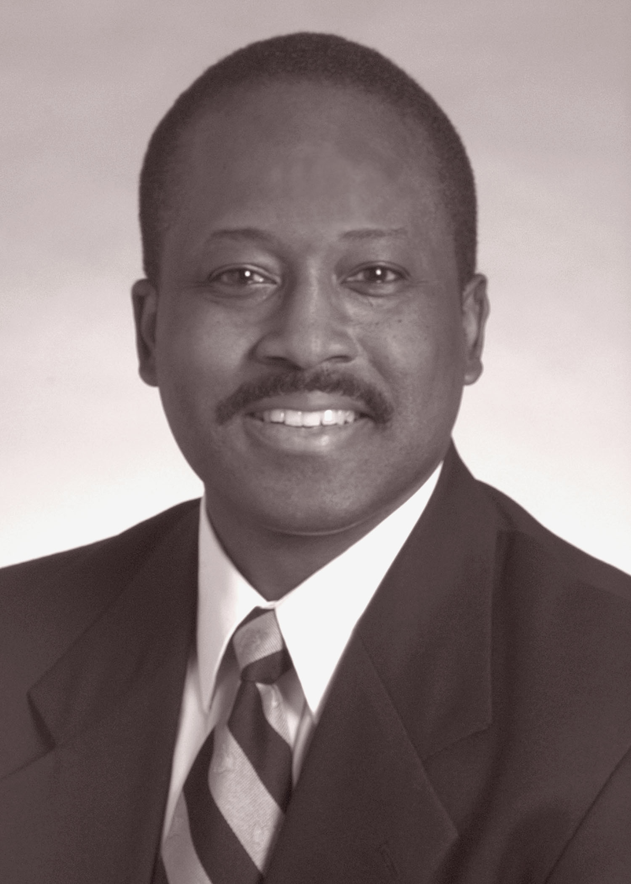
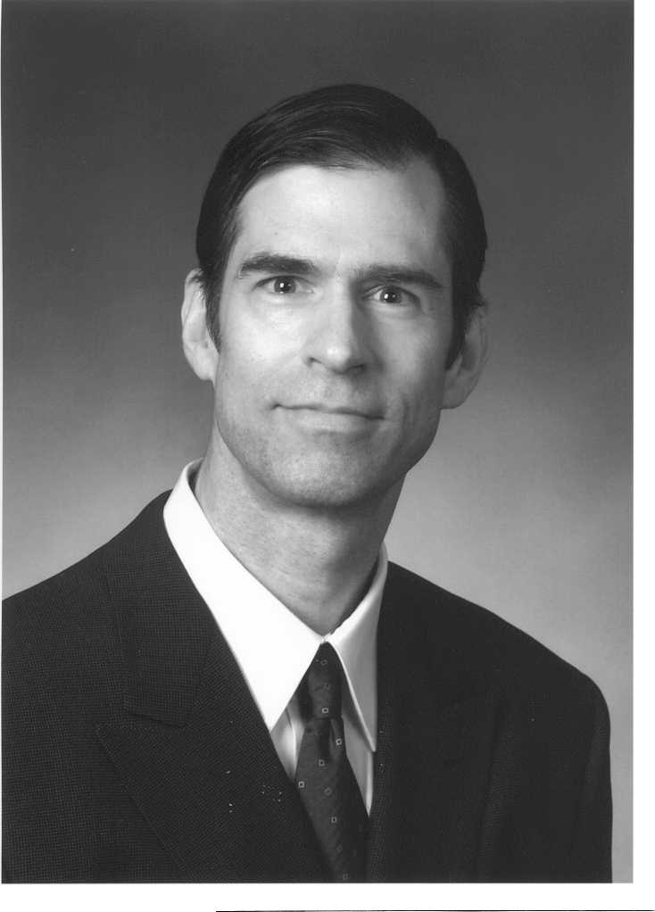

Howard W. Francis, MD Michael H. Fritsch, MD

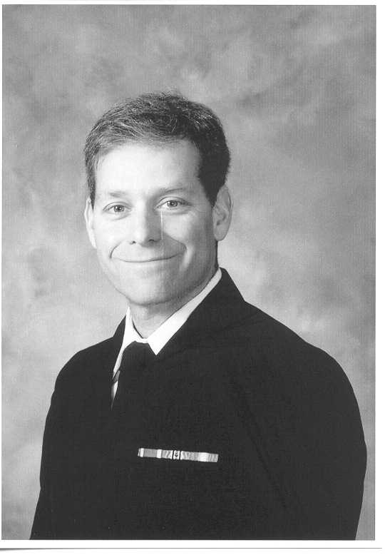
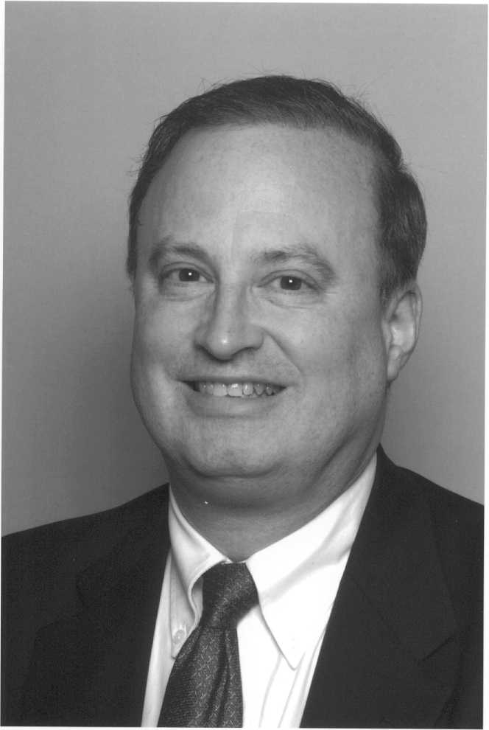

Micheal E. Hoffer, MD Christopher J. Linstrom, MD

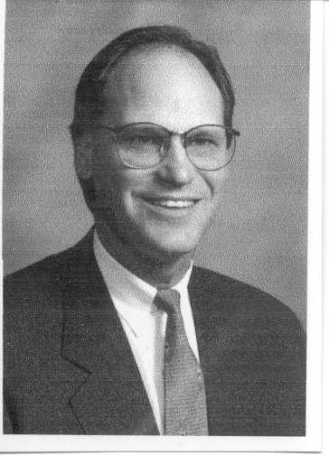
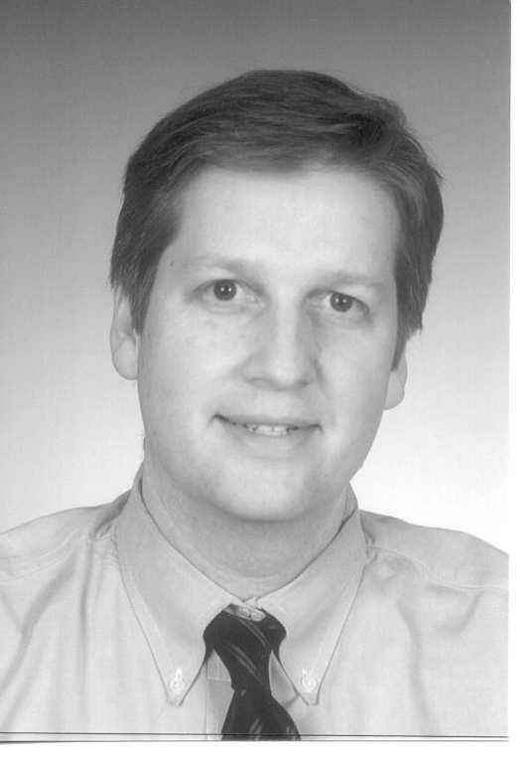

Gary F. Moore, MD G. Mark Pyle, MD

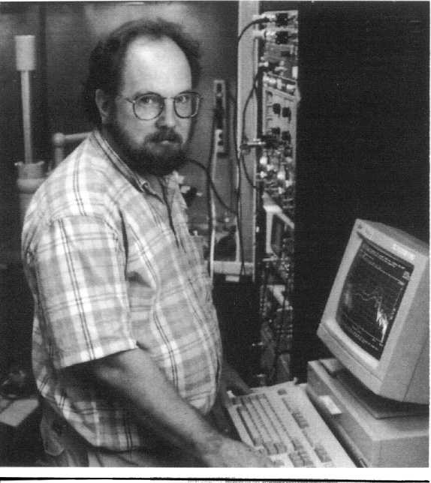
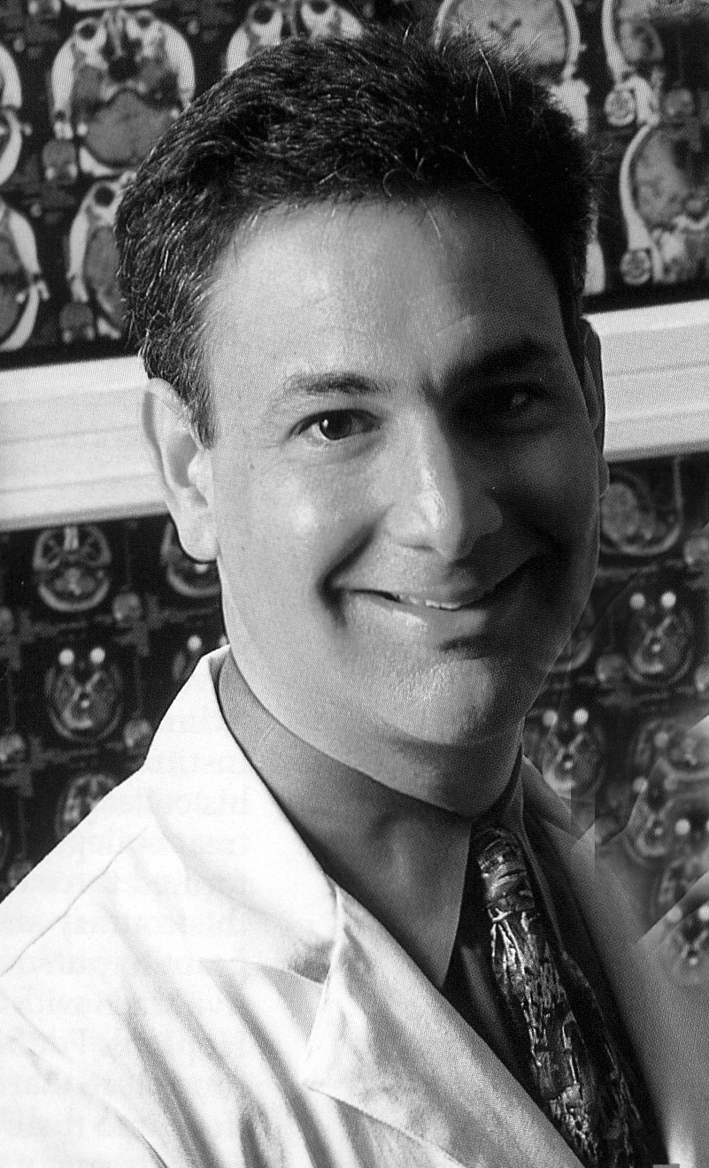

John J. Rosowski, PhD
Associate Member

Michael J. Ruckenstein, MD

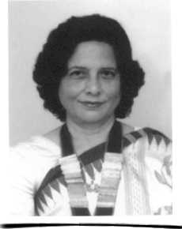
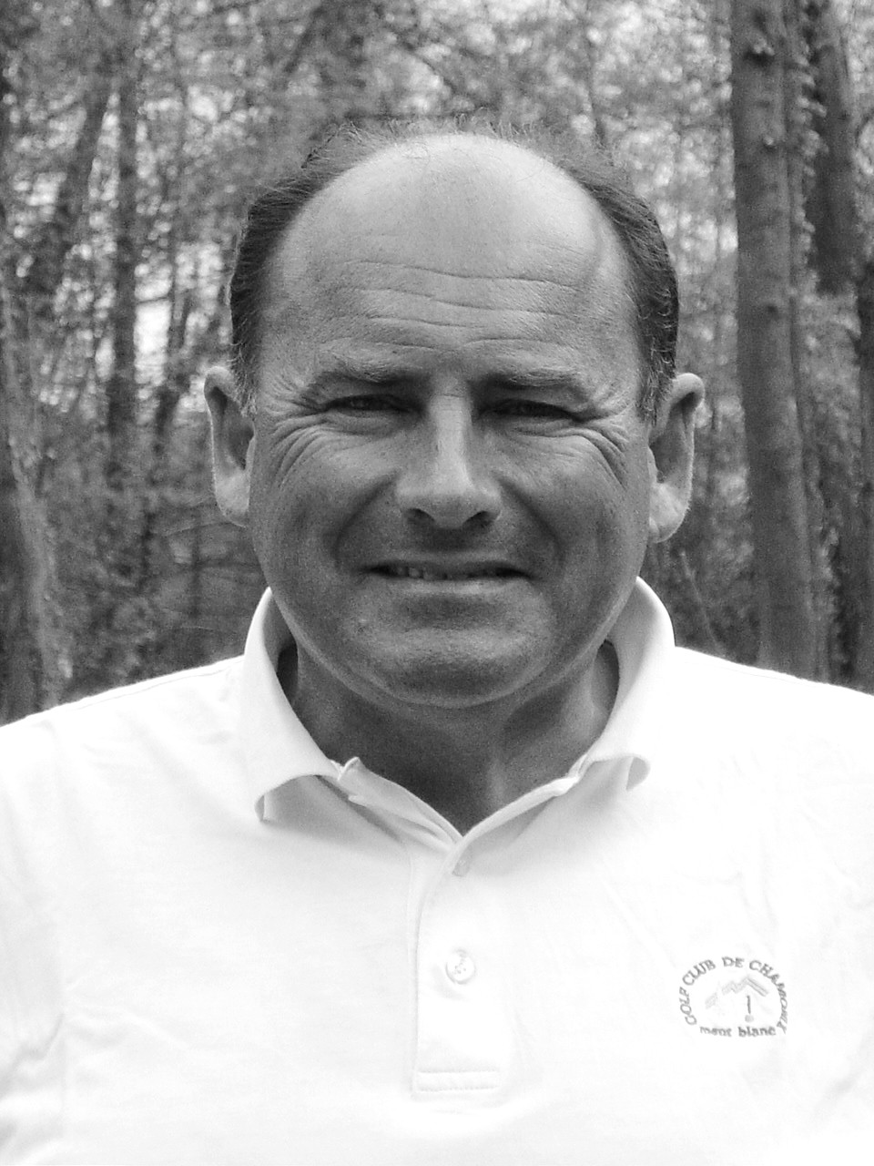

Sandra G. Desa Souza, MBMS
Corresponding Member Olivier Sterkers, MD. PhD
Corresponding Member

Deceased since 2002 Meeting

James A. Moore, MD

Became and Active Member of the American Otological Society in 1952 and a Senior Member in 1987. Date of death unknown.

Walter A. Rosenblith, MD

Became an Associate Member in 1970. Died 5/1/2002

